
April 2025


Dear Parents and Carers,
As I write this letter, the sun is shining, the birds are singing and there is a real spring in our steps as at last we have finally navigated our way through the miserable weather and the dark mornings and evenings of the winter season.

This term has been a particularly busy one for the whole school community at St Wilfrid’s, as you will all know the school had a two day Catholic Schools Inspection on12th and 13th February 2025. Two Inspectors were in school for these two days to observe and to speak with Staff, Pupils and members of the Governing Body in relation to the Catholic Life and Mission, Religious Education and Collective Worship of the school.
I am really delighted to share with you all that the inspectors recognised the outstanding Catholic life and Mission Religious Education and Collective Worship of our school. The report is a huge testament to all of the hard work and dedication From all our staff, governors, pupils and you as parents and carers.
To achieve “Outstanding” in all 9 areas of our inspection really does reflect the strong Catholic ethos and values that truly underpin every area of our school community.

We are so very proud of all the children, their behaviour during the inspection was exemplary and their enthusiasm really shone through and was truly wonderful to see.

Therefore, I would like to take this opportunity to “Thank You” you as Parents and Carers for your continued support and partnership in your children’s education. Please do take time to read the full inspection report a copy of which can be found on the schools website and to celebrate with us this wonderful and truly deserved recognition of our wonderful school.

Throughout this spring term, I have witnessed our children grow and continue steadily on their learning journey. Staff continue to provide the children with a high level of challenge and expectation across the whole school. With this continued hard work and commitment of the staff, alongside your valuable support learning at home, our children will be able to reach the high standards expected of them.
Therefore, I would like to take this opportunity to say “Thank you” to Mrs McEniff, Ms Davies, and all the Staff in whatever role they play in school, members of the Governing Body, PTFA, Parents, Carers and Friends of the School who contribute by supporting events and helping out when the need arises. The strong relationships that exist at St Wilfrid’s School continue to be one of its greatest strengths.

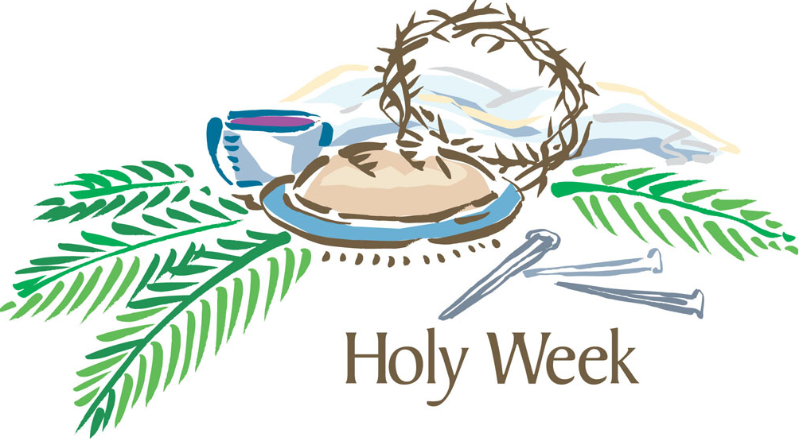
So, as we prepare for Easter, we remember the great sacrifice of Jesus dying on the cross to save us. Let us this Easter offer our welcome and support to the community and show the world that our faith is strong, alive and well.
Therefore, I pray that we will all keep Jesus at the centre of our family life, built on this foundation of true meaning of our faith, so that we can all the more appreciate our Easter Eggs and Holidays before the new term begins.

Finally on behalf of the Governing Body, may I wish you and your families
“A very Happy and Holy Easter”

May the glory
and the promise
Of this joyous time of year
Bring peace
and happiness to you
and those you hold dear

And may Christ
Our risen Saviour
always be there by your sides
To bless you
Most abundantly
And be your loving guide
Amen


Best Wishes
Elaine Morrissey
Chair of Governors

