The Safeguarding Team at St Wilfrid’s Catholic Primary School

“Education Staff have a crucial role to play in helping identify welfare concerns and indicators of possible abuse or neglect, at an early stage”
Working Together to Safeguard Children 2015

If you have any concerns about the health and safety of a child at this educational setting or feel that something may be troubling them, you should this information with an appropriate member of staff straight away. Some issues, for example, a child’s appearance, hygiene, general behaviour can be shared with any teacher or member of support staff in this setting. Do not worry that you may be reporting small matters- we would rather that you tell us things which turn out to be small than miss a worrying situation.
However, if you think the matter is serious and may be related to a child protection concern, where the child has been harmed or is at risk of harm, for example, physical, sexual, emotional abuse, neglect, domestic violence or radicalisation you must talk to one of the people below immediately. If you are unable to contact them you can ask the school office staff to find them and ask them to speak to you straight away about a confidential and urgent matter.
The people you should talk to at St. Wilfrid’s Catholic Primary are:The Designated Safeguarding Person
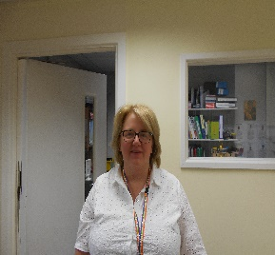 Mrs Justine McEniff
Her office is near the main office
Her telephone number is 01606 663630
If Mrs McEniff is not available the Deputy Designated Safeguarding Person is
Mrs Debbie Jackson
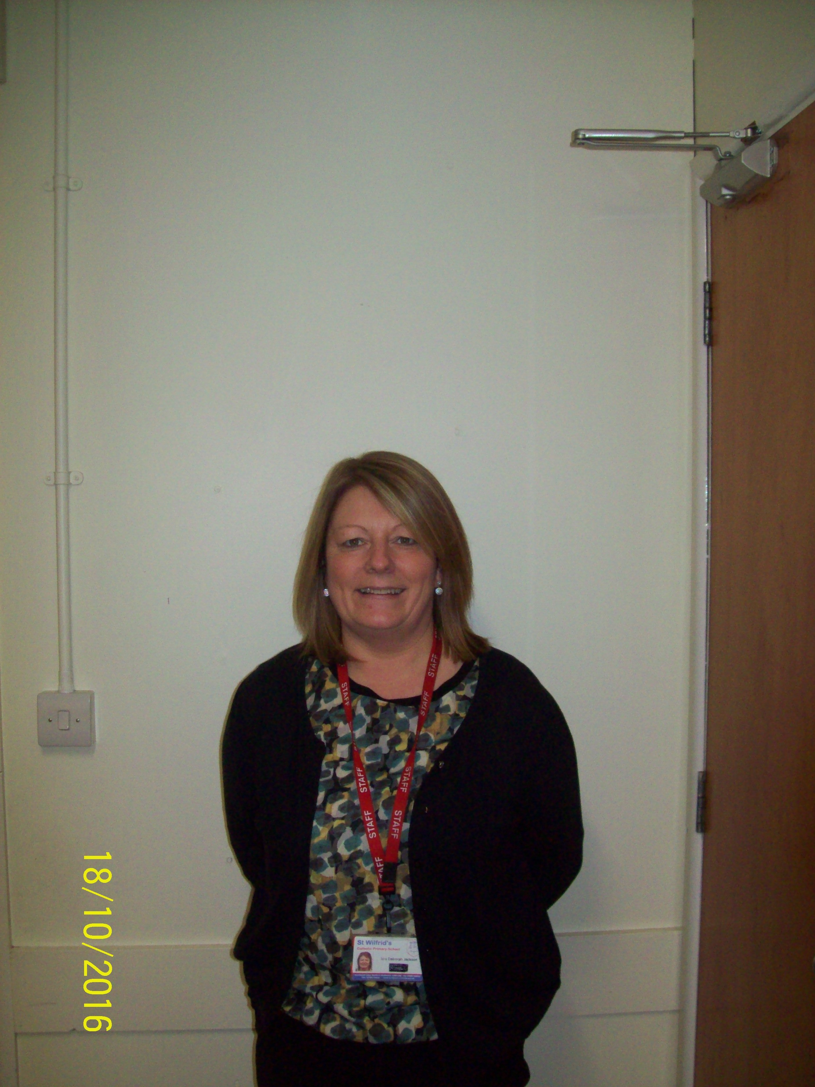
Her office is situated in the Verlarde Building Her Her telephone number is: 01606 663630

Any allegation or disclosure involving someone who works with children in a paid or voluntary capacity must be reported directly to the Head teacher or Deputy Head teacher, unless it involves them and then it should be reported directly to the Chair of Governors Mrs Elaine Morrissey.
Headteacher: Responsible for implementing policies and procedures allocating resources to the safeguarding team and addressing staff safeguarding concerns - Name: Justine McEniff

Designated Safeguarding Person (DSP): a member of the leadership team with appropriate training and who is responsible for dealing with safeguarding issues, providing advice and support for staff, liaising with the local authority and working with other agencies. - Name: Justine McEniff
Designated Safeguarding Deputy (DSD) : a member of staff with the appropriate training to effectively deputise for the DSP - Name: Paula Harkness – Deputy Headteacher
Designated Safeguarding Deputy (DSD) : a member of staff with the appropriate training to effectively deputise for the DSP - Name: Debbie Jackson, Family Liaison Officer
Special Educational Needs Coordinator (SENCO): member of staff who provides advice, liaison and support for school staff and other agencies working with pupils with special educational needs and their parents and carers - Name: Michaela Davies
Family Liaison Officer: (FLO): member of staff who addresses difficulties which prevent a child from reaching their potential, provides social, emotional support for children to enable them to overcome these barriers, supports parents and carers -Name: Debbie Jackson

Designated teacher for Looked After children (LAC): promotes the educational achievement of LAC, helps staff understand the issues that affect how they learn and achieve. Ensures appropriate staff have the information they need - Name: Justine McEniff
E Safety Coordinator: maintains and develops an e safe culture in school -Name: Justine McEniff
Safeguarding Governor: Ensures there are appropriate safeguarding policies and procedures in place, monitors whether they are being followed and together with the GB remedies deficiencies and weaknesses that are identified - Name: Elaine Morrissey

Chair of Governors: takes the lead in dealing with allegations of abuse made against the Headteacher and other members of staff when the Headteacher is not available, in liaison with the local authority and the Diocese of Shrewsbury, on safer recruitment practices with the Headteacher - Name: Elaine Morrissey

SCiE Safeguarding children in Education CWAC: provide advice and guidance on safeguarding matters - scie@cheshirewestandchester.gov.uk
Name: Kerry Gray Telephone: 0151 356 6843/6549

LADO Local Authority Designated Officer:
Deals with allegations against adults
Name: Pam Beech Telephone: 0151 356 6843/6549

Safeguarding at Diocese of Shrewsbury:
Name: Andrew O’Brien Telephone: 0151-652-9855

