love ~ joy ~ responsibility ~ creativity ~ respect ~ opportunity

St Wilfrid’s Catholic Primary School Maths Policy

Academic Year | Designated Senior Person | Deputy Designated Senior Person | Nominated Governor | Chair of Governors
2022-2023 | Justine McEniff | Paula Harkness | Elaine Morrissey | Elaine Morrissey

Policy Review Dates

Review Date | Changes made | By whom | Date ratified with FGB
September 2022 |  | L Ryan

MISSION STATEMENT
"I have come that they may have life and have it to the full"
John 10
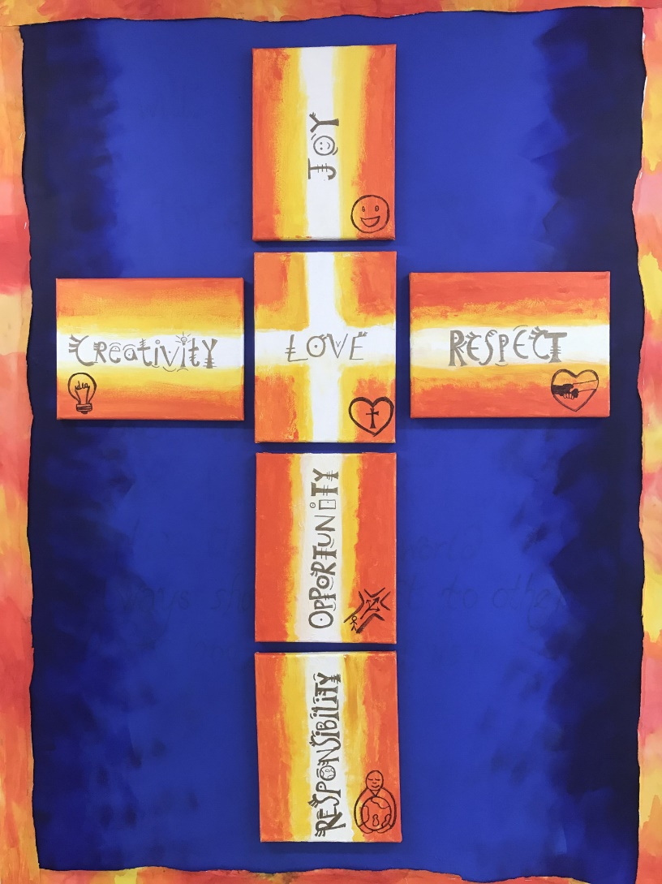
At St. Wilfrid’s we love one another,
show respect and accept responsibility.
Embracing opportunity and nurturing creativity,
we share in the joy of Jesus

The National Curriculum 2014
Purpose of study
Mathematics is a creative and highly inter-connected discipline that has been developed over centuries, providing the solution to some of history’s most intriguing problems. It is essential to everyday life, critical to science, technology and engineering, and necessary for financial literacy and most forms of employment. A high-quality mathematics education therefore provides a foundation for understanding the world, the ability to reason mathematically, an appreciation of the beauty and power of mathematics, and a sense of enjoyment and curiosity about the subject.
Aims
The national curriculum for mathematics aims to ensure that all pupils:
- become fluent in the fundamentals of mathematics, including through varied and frequent practice with increasingly complex problems over time, so that pupils develop conceptual understanding and the ability to recall and apply knowledge rapidly and accurately.
- reason mathematically by following a line of enquiry, conjecturing relationships and generalisations, and developing an argument, justification or proof using mathematical language
- can solve problems by applying their mathematics to a variety of routine and non-routine problems with increasing sophistication, including breaking down problems into a series of simpler steps and persevering in seeking solutions.

The National Curriculum sets out year-by-year programmes of study for key stages 1 and 2. This ensures continuity and progression in the teaching of mathematics.

The EYFS Framework in relation to mathematics aims for our pupils to:
- Count confidently, develop a deep understanding of the numbers to 10, the relationships between them and the patterns within those numbers.
- Develop their spatial reasoning skills across all areas of mathematics including shape, space and measures.
- Develop positive attitudes and interests in mathematics, look for patterns and relationships, spot connections, ‘have a go’, talk to adults and peers about what they notice and not be afraid to make mistakes.

Policy aims

- Children will develop a positive attitude towards maths and have an awareness of the relevance of mathematics across the curriculum and in the real world;
- Competence and confidence in using and applying mathematical knowledge, concepts and skills an ability to solve problems, to reason, to think logically and to work systematically and accurately;
- Confident communication of maths to apply their skills successfully in a range of reasoning and problem solving contexts.
- resilience, perseverance and an eagerness to investigate and learn from mistakes;

Lessons
Lessons involve elements of:
- Instruction – giving information and structuring it well;
- Demonstrating – showing, describing and modelling mathematics using appropriate resources and visual displays;
- Explaining and illustrating – giving accurate and well paced explanations;
- Questioning and discussing;
- Children explaining and reasoning;
- Consolidating;
- Reflecting and evaluating responses – identifying mistakes and using them as positive teaching points;
- Summarising – reviewing mathematics that has been taught enabling children to focus on next steps

- Teachers use the White Rose schemes of learning to ensure consistency, coverage and progression
- Additional high quality resources, such as NCETM, NRICH, Deepening Understanding, Third Space Learning and I see Reasoning may be used to ensure sustained levels of challenge
- (Y2 / Y3 / Y4 only) Use a brief starter activity to teach / rehearse / secure multiplication tables.
- Teach content in small bitesized chunks to aid understanding.
- Ensure lessons follow the fluency, reasoning, problem solving model, with all children having the opportunity to reason and problem solve at their level. Provide scaffolds, sentence stems and practical resources to support learners to achieve the expected standard in each objective.
- Use Concrete, Pictorial and Abstract manipulatives and visual images regularly to scaffold, support and challenge children accordingly.
- Use appropriate challenge, at all levels, to consolidate and stretch. Use high quality resources from a range of approved websites and mathematical providers such as White Rose and NCETM.
- Ensure observations, high quality questioning immediate intervention marking throughout each lesson is used to identify misconceptions, support and provide additional challenge as required.

Expected standards in books
- In all lessons from Y1 - 6, learning objectives and success criteria are clearly displayed in books.
- Model and expect one digit per square, all straight lines to be drawn with a ruler, children to write using a sharp pencil, calculations to be numbered and appropriately spaced, new page for a new lesson in most occasions.
- Use sheets in books only if vital – encourage writing directly into books wherever possible. Reasoning and problem activities to be cut and stuck in books and then responses to be in full sentences underneath across the page. Full sentences to replicate sentences in English books.

Marking
- Marking of children’s work is essential to ensure they make further progress. Work is stamped against success criteria, in line with the school marking policy.
- Children are encouraged to self-assess their work and are given time to make corrections or improvements. Some pieces of work in mathematics can be marked by children themselves, exercises involving routine practice with support and guidance from the teacher.
- Ongoing assessments inform future planning and teaching. Lessons are adapted readily and short term planning evaluated in light of these assessments.

Displays
- Display a Maths Working Wall with current and relevant maths, which supports children’s learning.
- Display images from the calculation policy as they are taught and update as necessary.
- Display numberlines appropriate to the year group.
- Actively engage children with displays and ensure they see them as an additional resource to support their learning and that they can access them independently as required.
- Display and regularly refer to important mathematical language relevant to each year group.
Calculation Policy
- Use the ‘Visual Calculation Policy’ when teaching any of the four operations and follow it’s expectations / methods precisely. (for both mental and written calculations)
- Refer to previously taught strategies from lower years and use these as baseline when teaching new methods.

Assessment
Teachers may choose to complete end of block assessments, produced by White Rose, which can be used to help inform their teacher assessment of each topic and identify any gaps in learning. End of term tests produced by White Rose can also be used for this purpose. Children are teacher assessed in Mathematics as B (below age related expectations) A (At age related expectations or E (Exceeding age related expectations).
Termly assessments are carried out using PUMA assessment materials in Years 1- 5. This assessment produces a termly standardised score, with a score of 100 being working at age related expectations. Whilst these PUMA assessments don’t always match the termly schemes of learning, they show the progress and attainment for that child over the year.
Teachers can use the standardised scores alongside judgements made from class work to support teachers’ assessment.
Data from each year group is recorded in ‘O-Tracker’ where SLT, the Maths Co-ordinator and teachers can access data for individual children as well as cohorts. Data can be tracked back and allows monitoring of school achievement.
Y2 and Y6 complete the national tests (SATs) in May.’

Equal Opportunities
Positive attitudes towards mathematics are encouraged, so that all children, regardless of race, gender, ability or special needs, including those for whom English is a second language, develop an enjoyment and confidence with mathematics.
The aim is to ensure that everyone makes progress and gains positively from lessons and to plan inclusive lessons. Lessons involving lots of visual, aural and kinaesthetic elements will benefit all children including those for whom English is an additional language (EAL).

Special educational needs & disabilities (SEND)
Daily mathematics lessons are inclusive to pupils with special educational needs and disabilities. Teachers are aware of children who require additional learning support and plan accordingly.
Children who are working significantly below their age expectations have focused lessons based on individual targets which incorporate objectives from the NC at a suitable pitch. Progress and attainment in maths for children with SEND is measured using B-Squared.
It is the teachers’ responsibility to ensure that all children are challenged at a level appropriate to their ability. Examples of this may include: questioning the children, differentiated activities that provide different levels of challenge, differing levels of support or extension activities, provision of manipulatives.

Role of the Maths Subject Leader
- To lead in the development of maths throughout the school.
- To monitor the planning, teaching and learning of mathematics throughout the school.
- To help raise standards in maths.
- To provide teachers with support in the teaching of mathematics.
- To provide staff with CPD opportunities in relation to maths within the confines of the budget and the School Improvement Plan
- To monitor and maintain high quality resources.
- To keep up to date with new developments in the area of mathematics

