Book Fair
GET READY FOR THE
AGES 2 +
Your Book Fair is coming, so it’s time to get excited! This list gives you and your class the opportunity to browse the Book Fair selection ahead of time, minimising the need for pupils and parents to touch the books on the bookcases during the COVID-19 pandemic.

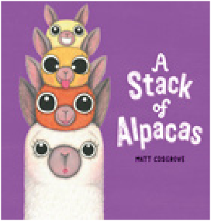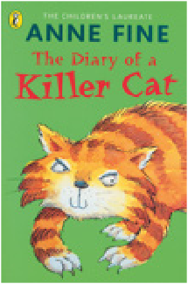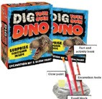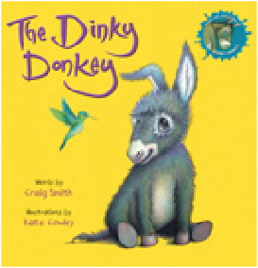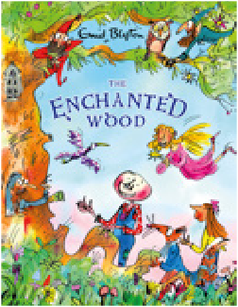

A Stack of Alpacas
£6.99
Diary of a Killer Cat, The
£2.99
Dig Your Own Dino Activity Kit
p £5.99
Dinky Donkey, The
£6.99
Enchanted Wood, The
£5.99

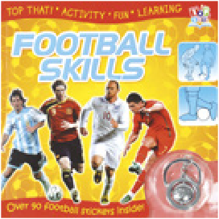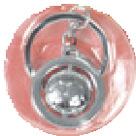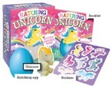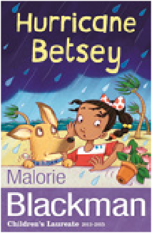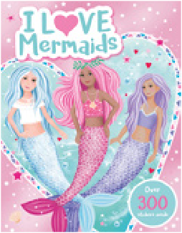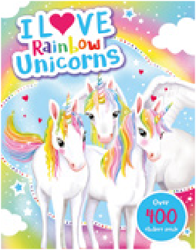
With FREE
keyring

Football Skills Sticker Activity Book
p £3.99
Hatching Unicorn
p £5.99
Hurricane Betsey
£2.99
I Love Mermaids!
Activity Book
p £4.99
I Love Rainbow Unicorns! Activity Book p £5.99

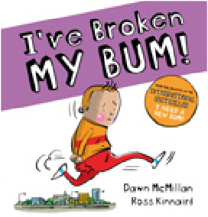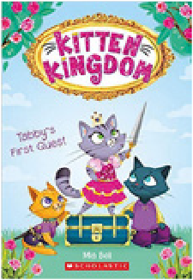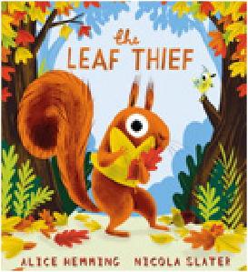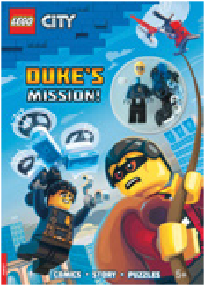
With FREE miniﬁgure
With FREE miniﬁgure

I’ve Broken My Bum!
£4.99
Kitten Kingdom: Tabby’s First Quest
£2.99
Leaf Thief, The
£6.99
LEGO® City:
Duke’s Mission Age 5+
p £6.99
LEGO® City: Fighting the Flames Age 5+
p £6.99

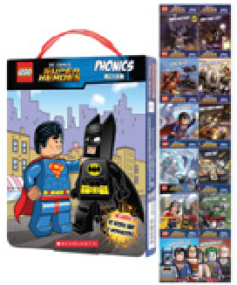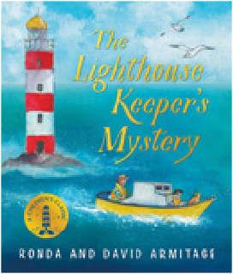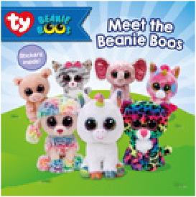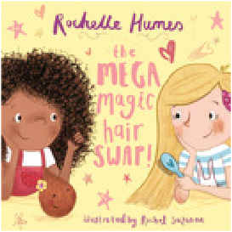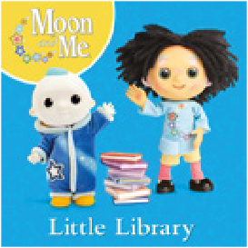

LEGO® DC
Superheroes: Phonics Box Set p £7.99
Lighthouse Keeper’s Mystery, The
£5.99
Meet the Beanie Boos
£4.99
Mega Magic Hair Swap, The
£6.99
Moon and Me: Little Library
£4.99

AGES 2 +

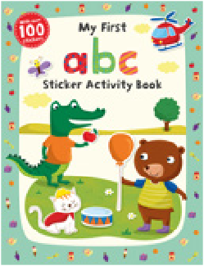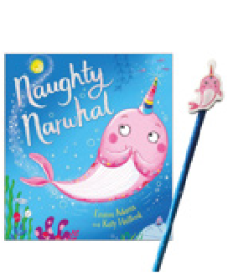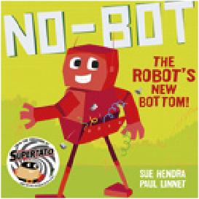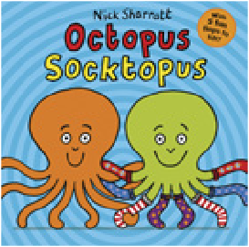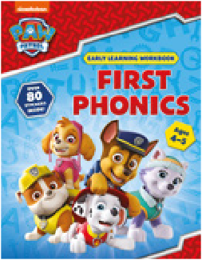

With FREE
pencil

My First ABC Sticker Book p £4.99
Naughty Narwhal
p £5.99
No Bot: The Robot’s New Bottom
£6.99
Octopus Socktopus
£6.99
Paw Patrol: First Phonics Ages 4 to 5 Workbook p £4.99

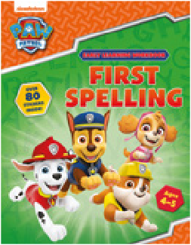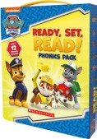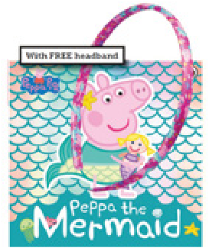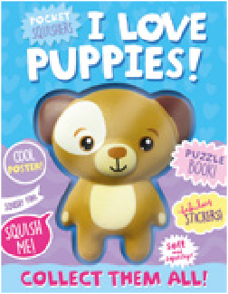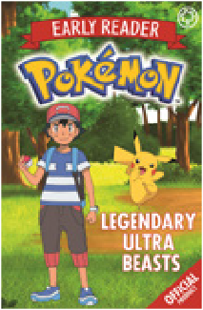

With FREE hairband

Paw Patrol: First Spelling Ages 4 to 5 Workbook p £4.99
Paw Patrol: Ready, Set,
Read! Phonics Pack
p £7.99
Peppa the Mermaid
p £6.99
Pocket Squishers:
I Love Puppies
p £5.99
Pokémon Early Reader: Legendary Ultra Beasts £4.99

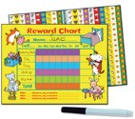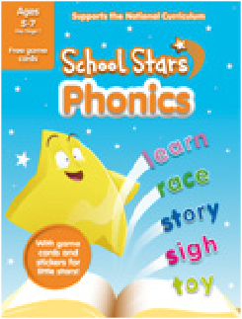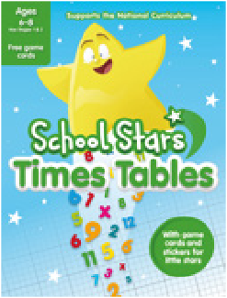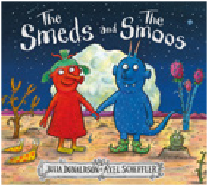

Hardback only
£6.99

Reward Chart
p £4.99

p £4.99
School Stars:
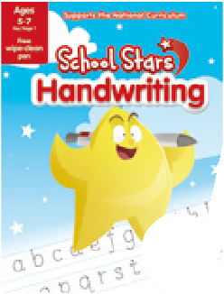
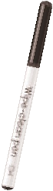
Phonics

School Stars: Handwriting
pen
E
an
With FRE wipe-cle
p £4.99
School Stars: Times Tables p £3.99
Smeds and the Smoos, The
£6.99

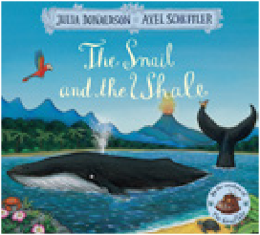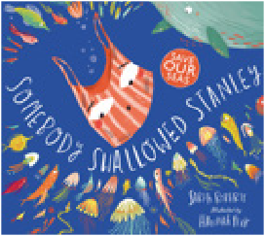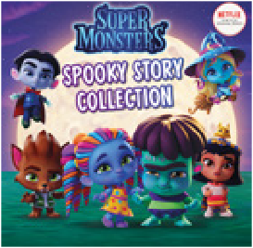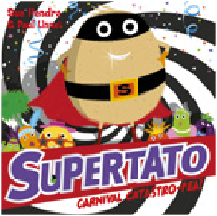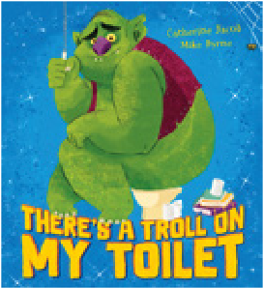

Snail and the Whale, The
£6.99
Somebody Swallowed Stanley
£6.99
Super Monsters: Spooky Stories Collection £5.99
Supertato: Carnival Catastro-Pea
£6.99
There’s a Troll on My Toilet
£4.99

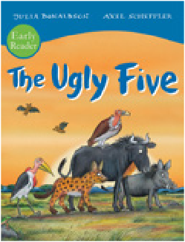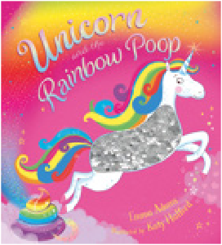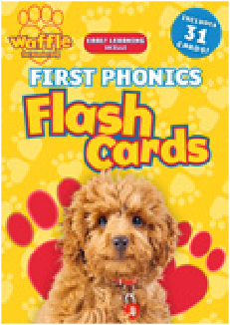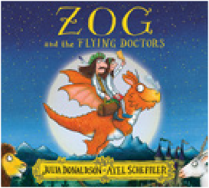

Ugly Five, The (Early Reader)
£4.99
Unicorn and the Rainbow Poop
p £6.99
Wafhe the Pop Dog
£5.99
Wafhe: First Phonics Flash Cards
p £5.99
Zog and the Flying Doctors
£6.99

AGES 6+
Car Diary

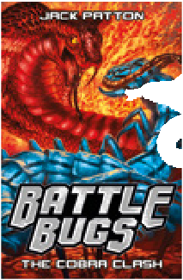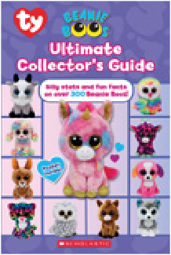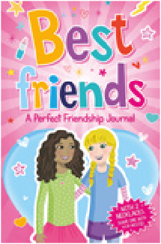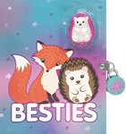
With FREE cobra toy

With 2 necklaces! Share one with
your bestie

Battle Bugs: The Cobra Clash
p £4.99
Beanie Boos: Ultimate Collector’s Guide
£6.99
Best Friends: A Perfect Friendship Journal
p £6.99
Besties Diary
p £6.99

p £5.99

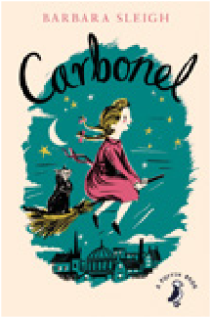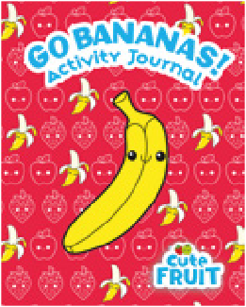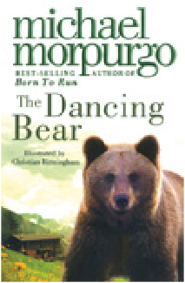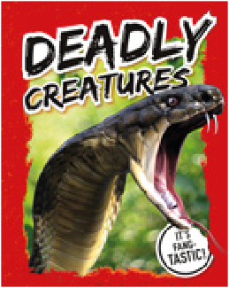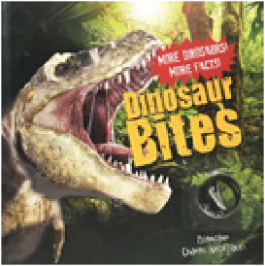

With FREE
snake
fang

With FREE dinosaur tooth necklace

Carbonel
£3.99
Cute Fruit: Go Bananas! Activity Journal p £6.99
Dancing Bear, The
£4.99
Deadly Creatures
p £5.99
Dinosaur Bites
p £6.99

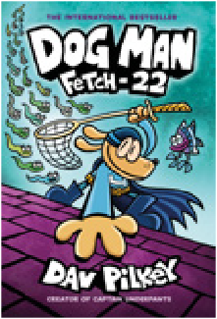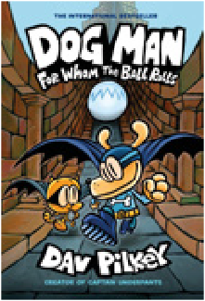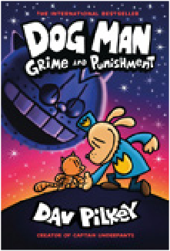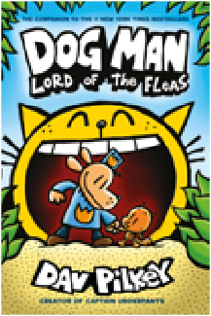

Dog Man: Fetch 22
£7.99
Dog Man: For Whom the Ball Rolls
£7.99
Dog Man: Grime and Punishment
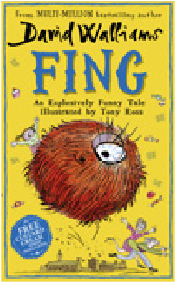
£7.99
Dog Man: Guide to Creating Comics in 3-D £6.99
Dog Man: Lord of the Fleas
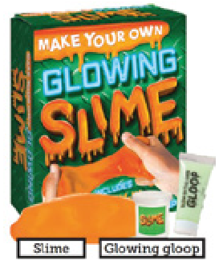
£6.99

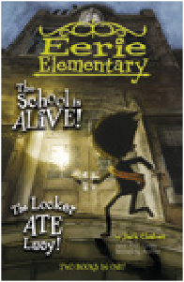

Two books
in one

Eerie Elementary: The School is Alive! & The Locker Ate Lucy!
i
th FREE klace
W
nec
£3.99

Enchanted Pony Academy: Wings That Shine p £4.99

Fing
£7.99

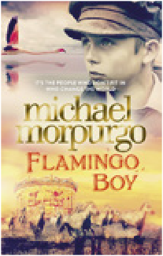
Flamingo Boy
£6.99

Glowing Slime
p £5.99

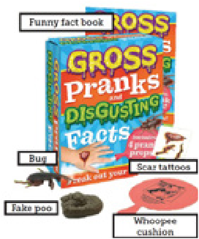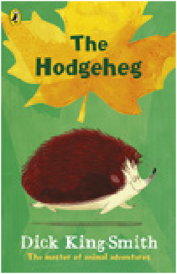

Gross Pranks and Disgusting Facts Kit p £5.99
Harry Potter: The Wand Chooses the Wizard p £9.99
Hidden Gems
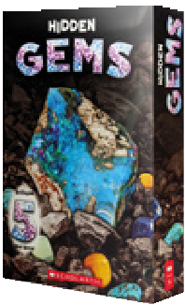
p £9.99
Hodgeheg, The
£2.99
Horrible Geography: Planet in Peril
£4.99

AGES 6+

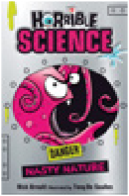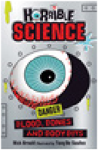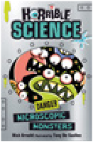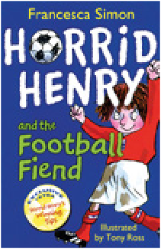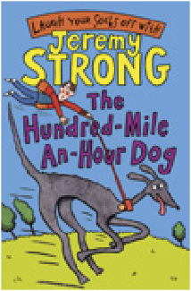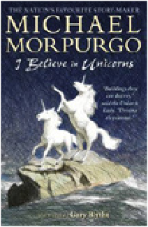

Horrible Science Reloaded (pack of 3)
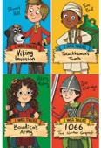
£5.99
Horrid Henry and the Football Fiend
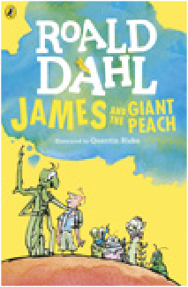
£5.99
Hundred Mile An Hour Dog, The
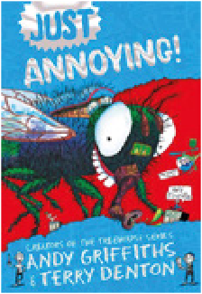
£2.99
I Believe in Unicorns
£5.99

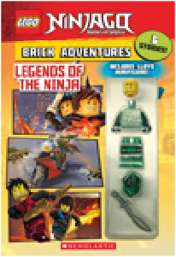

e
With FREE miniﬁgur

I Was There (pack of 4)
£5.99

James and the Giant Peach
£4.99

Just Annoying
£6.99
LEGO® Ninjago® Brick Adventures: Legends of the Ninja
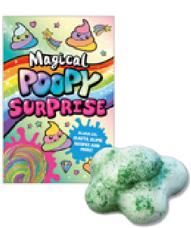
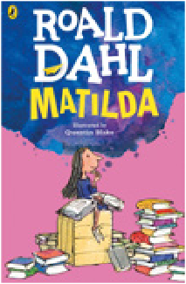
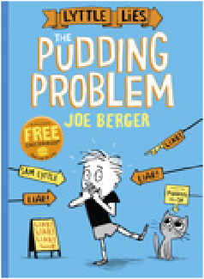
p £6.99

With FREE
putty

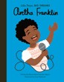
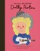
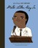
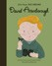
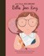
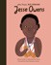
Little People, Big Dreams Pack (pack of 6)
£14.99

Lyttle Lies: The Pudding Problem
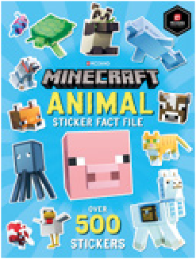
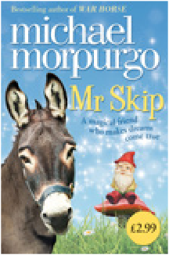
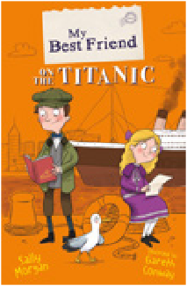
£2.99

Magical Poopy Surprise
p £5.99

Matilda
£6.99

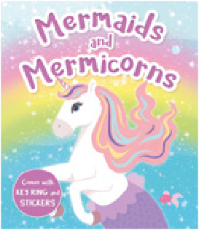

Mermaids and Mermicorns Journal
p £5.99
Minecraft Animal Sticker Fact File
p £7.99
Mr Skip
£2.99
My Best Friend on the Titanic
£2.99

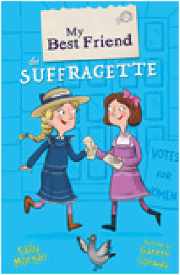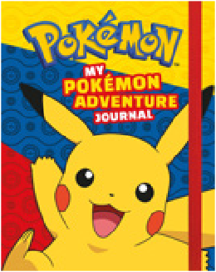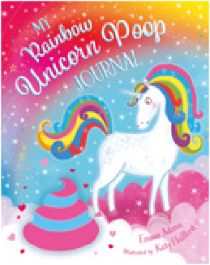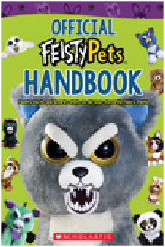

My Best Friend the Suﬀragette
£2.99
My Pokémon Adventure Journal
£6.99
My Rainbow Unicorn Poop Journal
p £6.99
Official Feisty Pets Handbook
£3.99

AGES 6+

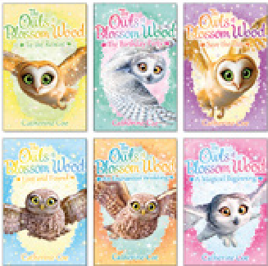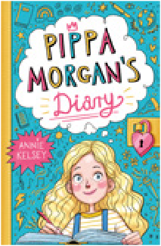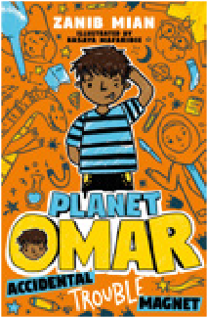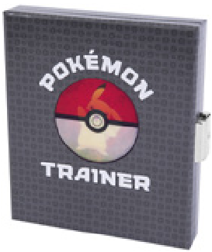

Owls of Blossom Wood, The (pack of 6)
£7.99
Pippa Morgan’s Diary
£5.99
Planet Omar: Accidental Trouble Magnet £4.99
Pokémon Trainer Lockbox Journal p £7.99

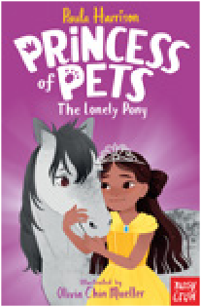

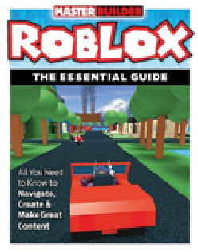
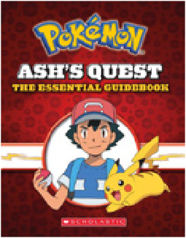
Pokémon: Ash’s Quest: The Essential Guidebook £6.99

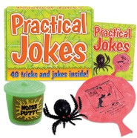
Practical Jokes
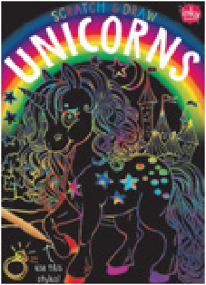
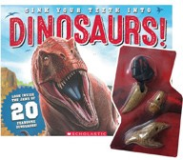
p £5.99
Princess of Pets:
The Lonely Pony
£5.99
Puppy Fun:
My Secret Diary
p £5.99
Puppy Love: My
Adorable Journal
p £5.99

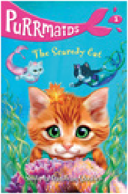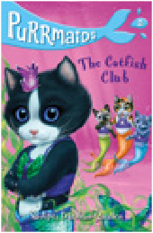

Purrmaids Pair (pack of two)
£3.99
Roblox: The Essential Guide
£8.99
Scratch and Draw: Unicorns
p £5.99
Sink Your Teeth Into Dinosaurs p £5.99

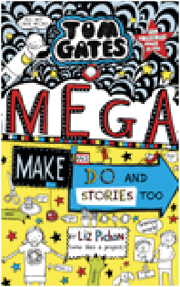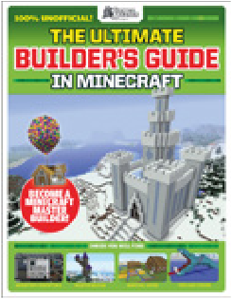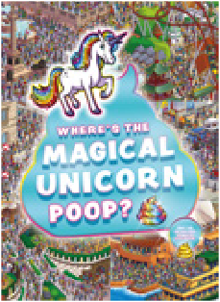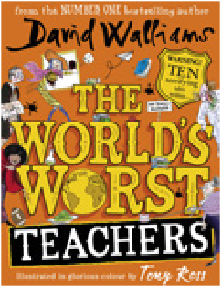

Tom Gates: Mega Make and Do
£6.99
Ultimate Builder’s Guide in Minecraft, The £7.99
Unicorns of Blossom Wood, The (pack of 4)
£5.99
Where’s the Magical Unicorn Poop?
£6.99
World’s Worst Teachers, The
£9.99

AGES 8+

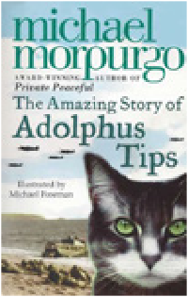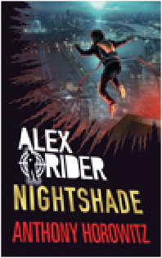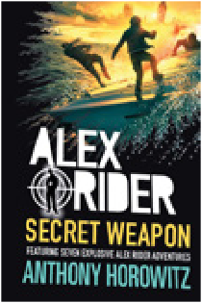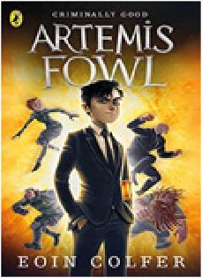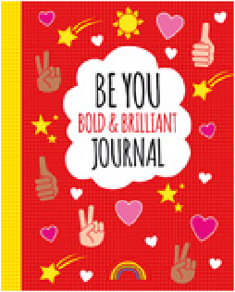

Adolphus Tips
£2.99
Alex Rider: Nightshade
£7.99
Alex Rider: Secret Weapon
£7.99
Artemis Fowl
£4.99
Be You: Bold and Brilliant Journal
£5.99

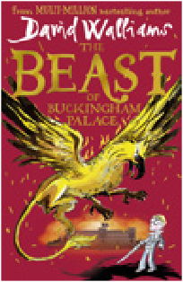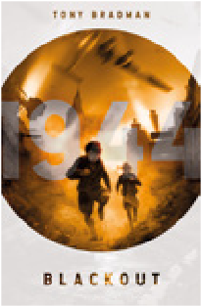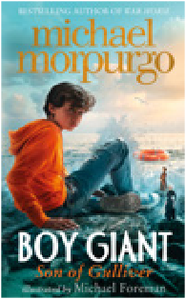

Beast of Buckingham Palace, The £7.99
Berlin Olympics, The
£4.99
Blackout!
£4.99
Blitz
£4.99
Boy Giant
£6.99

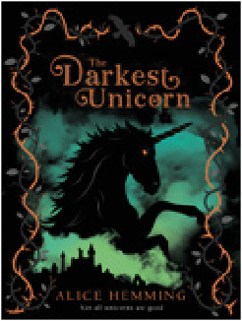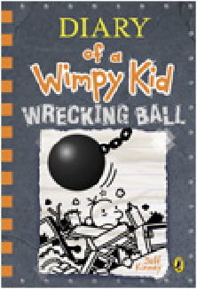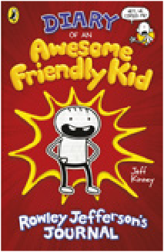

Colossal Crystals
p £9.99
Darkest Unicorn, The
£6.99
Dazzling Dreams Trifold Notebook p £6.99
Diary of a Wimpy Kid: Wrecking Ball £7.99
Diary of an Awesome Friendly Kid £7.99

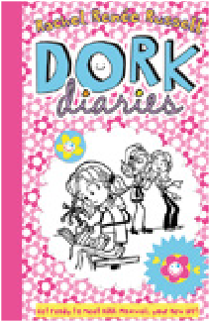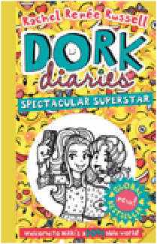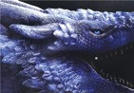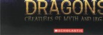
With FREE medallion necklace

Dork Diaries
£2.99
Dork Diaries: Spectacular Superstar £6.99
Dragons! Creatures of Myth and Legend p £5.99
Evacuee
£4.99

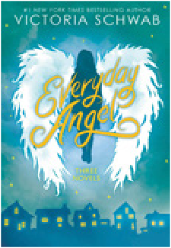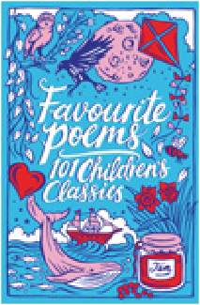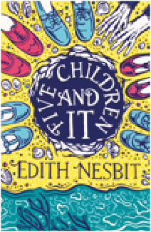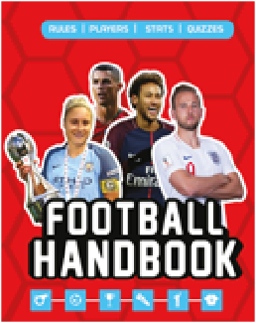

Everyday Angel
£4.99
Favourite Poems: 101 Children’s Classics
£2.99
Five Children and It
£2.99
Football Handbook
£5.99
Free Rein:
Fight to the Finish
£4.99

AGES 8+

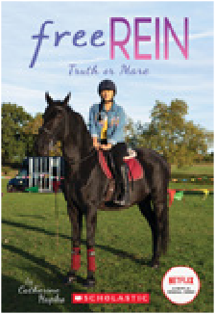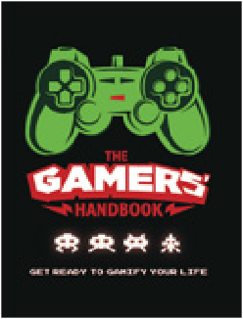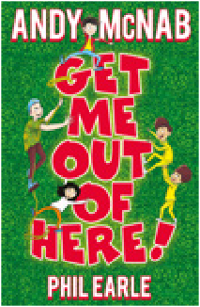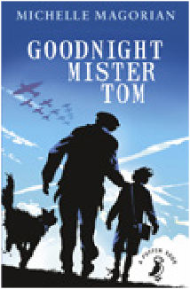

Free Rein: Truth or Mare
£4.99
Furry Ice Cream Sloth Trifold Notebook
p £7.99
Gamers’ Handbook, The
£5.99
Get Me Out of Here!
£6.99
Goodnight Mister Tom
£2.99

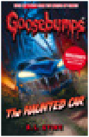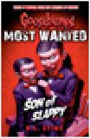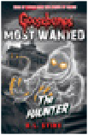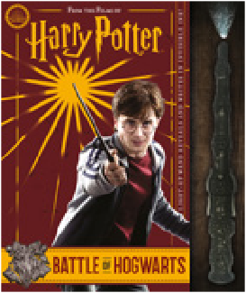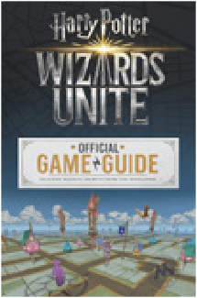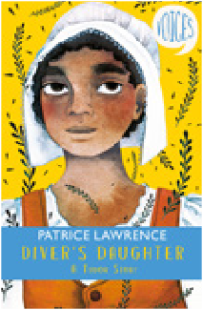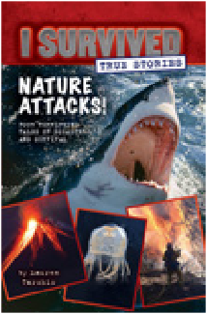

With
FREE wand

Goosebumps (pack of 4)
£9.99
Harry Potter: Battle of Hogwarts p £9.99
Harry Potter: Wizards Unite: The Official Game Guide £4.99
Hidden Voices: Diver’s Daughter
£4.99
I Survived: Nature Attacks!
£4.99

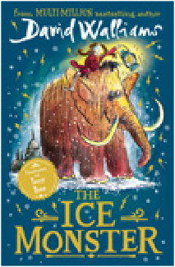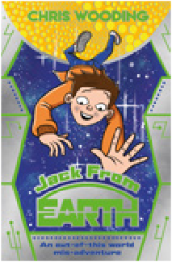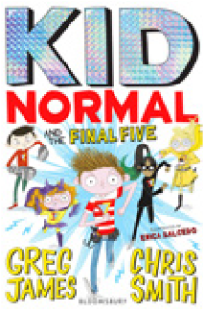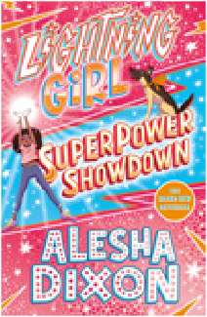

Ice Monster, The
£7.99
Jack from Earth
£4.99
Jamie Johnson (pack of 5)
£9.99
Kid Normal and the Final Five
£6.99
Lightning Girl: Superpower Showdown £4.99

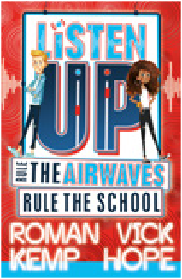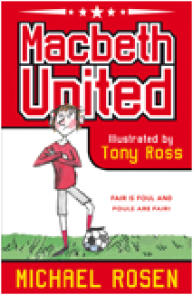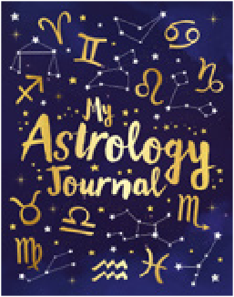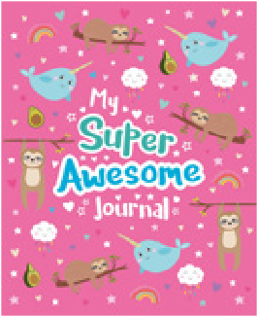

Listen Up
£6.99
Macbeth United
£6.99
Mulan: Novel of the Film
£6.99
My Astrology Journal
£5.99
My Super Awesome Journal
£5.99

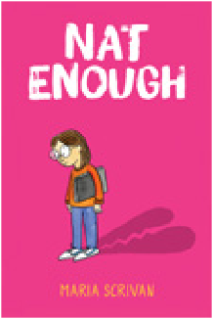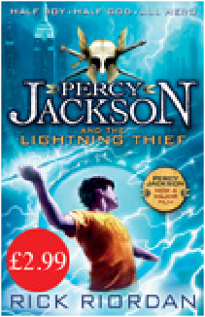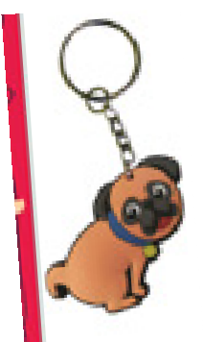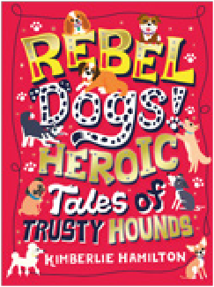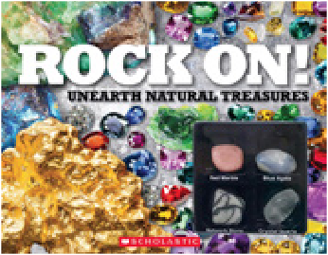
With FREE keyring

Nat Enough
£8.99
Percy Jackson and the Lightning Thief
£2.99
Rebel Dogs
p £6.99
RockOn!:
Rocks & Mineral
p £6.99

AGES 8+

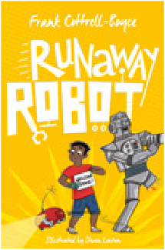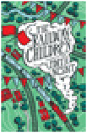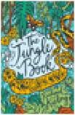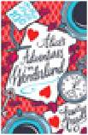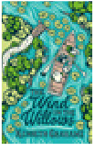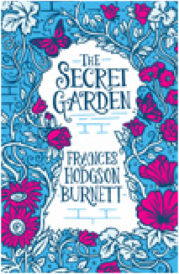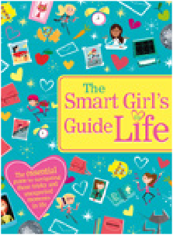

Runaway Robot
£6.99
Scholastic Classics (pack of 4)
£9.99
Secret Garden, The
£2.99
Shoe Wars
£7.99
Smart Girl’s Guide to Life, The
£6.99

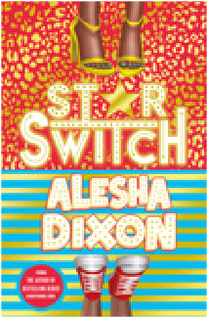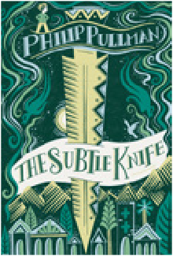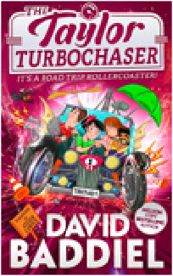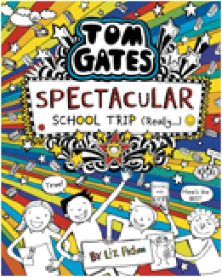

Hardback only
£7.99

Star Switch
£6.99
Stories From Around the World
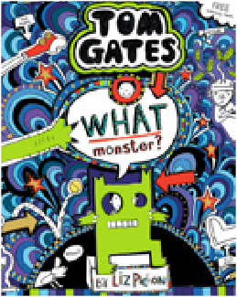
£2.99
Subtle Knife, The
£4.99
Taylor Turbochaser, The
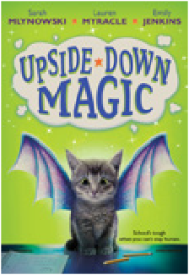
£6.99
Tom Gates: Spectacular School Trip (Really.) £7.99

Tom Gates: What Monster?
£6.99
Ultimate Guide to Women’s Football, The
£6.99
Unicorn Glitter Shaker Confetti Diary p £6.99
Upside Down Magic
£5.99
Warning
8-bit Diary
£6.99

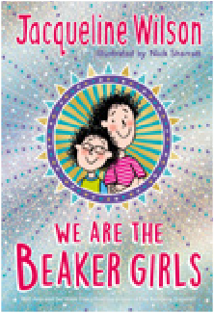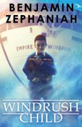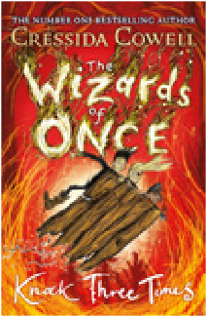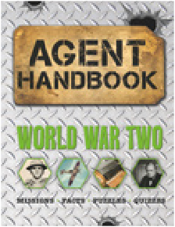

We Are the Beaker Girls
£6.99
Windrush Child
£4.99
Wizards of Once, The: Knock Three Times £7.99
World War Two Agent Handbook
£5.99
You Go, Girl!
£5.99

Book range may vary. All books subject to availability. p Warning: Not suitable for children under 3. Small parts.

YOUR ORDER

If you join your school’s Book Fair order you’ll benefit from FREE P+P to your school! Just fill in the order form and return it to your school and make payment by calling the telephone number below.

Do not send payments into school.

Title | Price | Quantity | Total
 | Total order value:

Child’s name: | Class:
Parent’s name:
School name: | School postcode:

Please tell us how you’d like to pay and give details below:

Pay by Phone:
Call 0333 305 2963
Please have your school’s Customer I.D. number ready together with a pen to record your transaction code.

You will be asked for your card number, expiry date, the three digit security number on the back of your card and amount you wish to pay. This call will be charged at your standard mobile rate.

Name: | School Customer  I.D. number. : 11504131
Transaction code: | Transaction  value: £

