Reading Domino
Challenge
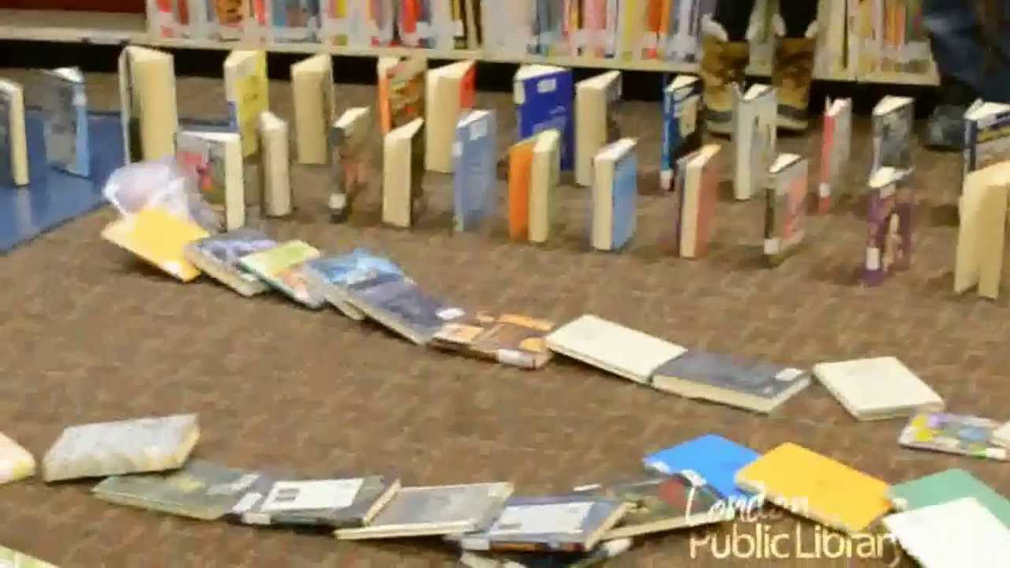
Stand your books up around the house. How far does your
‘Reading River’ stretch?
Read the last book to fall down with someone in your family.
Have Fun!!!!

