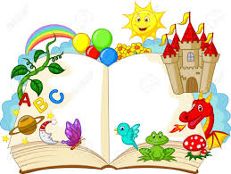
Book Scavenger Hunt

Have a look on your bookshelf. Can you find…
- A book with an animal as the main character.
- A book with a dragon in it.
- A book with more than 150 pages.
- A book with a queen in it.
- A book which rhymes.
- 3 books by the same author.
- A book with a title which is 5 words.
- A book with a name as a title.
- A book which tells you faces.
- A book with a colour in the title.
- A book with a girl as the main character.
- A book with a boy as the main character.
- A book with an index.
- A book with a contents page.
- A book with a funny title.
- A book with your favourite animal in it.
- A book with an item of food in the title.
- A book with a sport in the title.

Good Luck!

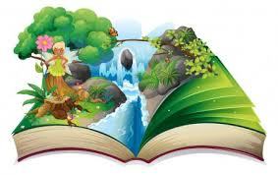

Record of Books

