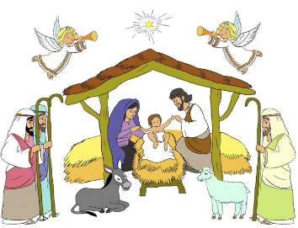
December 2021

Dear Parents and Carers,
Christmas is the time of year when we remind ourselves of the good sentiments customarily associated with this very special celebration. One of my favourites is the wish of the Angels which is for “Peace on Earth and Goodwill to Mankind” We don’t often use the word “goodwill” in our daily lives, but kindness is another good way of expressing goodwill.
As Chair of Governors, I don’t always get things right, but I do try on a daily basis to be kind and generous to others.
A good education is one of the best possible starts that we can give our children and I feel that Mrs McEniff and all the Staff at St Wilfrid’s School are in a very real way being kind towards the Children. It is hopefully a kindness that will reap great rewards for a lifetime.
Teaching our children how to behave both inside and outside of the school is also an act of kindness, as it is preparing them how to be good citizens of the 21st century, so that they in turn may be kind and generous towards others.
Peace on Earth may seem hard to achieve but every one of us, no matter how young or how old, can do their best to be a Peacemaker whether it be in your own family or the wider community.
So, what one change could you make to your life in 2022 to help bring
“Peace on Earth”
Mrs McEniff, Ms Davies, the Senior Leadership Team and all the Staff are working extremely hard to provide an essential balance for your child’s learning and development. However, there are wider skills, attitudes and understanding that must not be forgotten. Your children are given really important opportunities to develop these through physical, creative and emotional growth. These opportunities continue to be developed and as Parents and Carers I thank you for your ongoing support and commitment.
I and the members of the Governing Body have also had a busy autumn term, whist we are still holding our regular meetings via Zoom we have been able to attend a Governor Development and Policy Review Day at the Parish Centre to review and ratify school policies and to participate in the development of the school SEF for 2021/22. We have also monitored the curriculum and school data, and looked at pupil, parent and community issues. Governors have also been able to attend two training events in school since the Pandemic began. I and several of the Governors have also been able to attend whole school masses which have been lovely and spiritually uplifting. Unfortunately, I had to make the difficult to postpone my planned visits tothe nativity celebrations for Pe-school/EYFS and Yr1/Yr2. Due to the rise of corona virus cases in school. However, I do hope that I will still be able to attend the Christmas Carol concert at St Wilfrid’s Church this coming Friday where will celebrate the true meaning of Christmas as a school community.
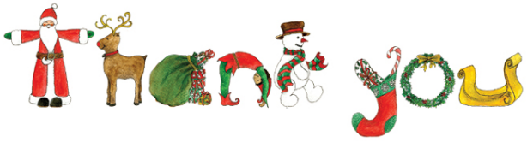

On behalf of the Governing Body, I am sure that you would like to join with me in thanking Mrs McEniff, Ms Davies and all the staff for their continued tremendous hard work and commitment to the children of the school during this term. Our dedicated team have put so much into making this school what it is ... they all work incredibly hard to ensure that all the children can achieve their best. This includes not only the Teachers and Teaching Assistants who work in the class rooms but also the Governing Body, Office Staff, EBNOC, Pre-school, Site Manager, Catering, Midday Assistants, Premises Staff, PTFA, YPTFA and Minnie Vinnies, each and every one of you all do a fantastic job in ensuring that St Wilfrid’s can offer such great opportunities to all our children. It is very much a whole team effort!! So, thank you.
As you all will be aware Mrs Harkness will be joining St Wilfrid’s School in January 2022 as our new Deputy Headteacher. So, I would like to say Thank you to Ms Davies for her commitment and support that she has given to Mrs McEniff during this term as acting Deputy Headteacher. I and the Governing Body are very grateful to Ms Davies.
I would also like to thank you our supportive parents and carers. We are so lucky at St Wilfrid’s to have such a richly diverse community and I have really enjoyed seeing the school’s partnership with parents and carers strengthen over the last few years, which has helped to ensure the very best outcomes for our children. By working together, we can ensure that our children enjoy their time at school, make good progress and leave us as responsible, well qualified, mature young people, ready to make a valued contribution to society. We have received so many positive comments about the children’s behaviour and attitude from a range of visitors to the school and you should feel very proud of them all.
A huge vote of thanks must also be given to Mrs Higgins and all the members of the PTFA for once again for organising a very successful Gin night and a whole host of exciting events this term including the Christmas raffle to raise funds for our new outdoor classroom. Thanks to you our families and the wider school community for supporting yet again these wonderful events inspite of covid restrictions. I would also like to thank our YPTFA for organising the Christmas fun afternoon for all the children in the school I understand everyone had a lovely time.
Farewell & Good Luck
Mrs Davies our part time year 6 teacher who began teaching at St Wilfrid’s School in 2002 has decided that all good things must come to an end and will sadly be leaving our school community at the end of this term. Mrs Davies has ensured that every child within her care has been given the opportunity to develop their own individual gifts and talents whilist delivering the highest level of teaching. So I would like to say “Thank you” and we as a school community will miss you but we all wish you every success Mrs Davies for the future.

Finally, it just leaves me to say on behalf of all the members of the Governing Body to wish you and all your families a very,
“Happy and Holy Christmas and a Peaceful and Prosperous New Year.”
Best Wishes
Mrs Morrissey
Chair of Governors
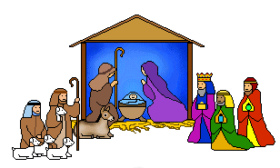

“May we be in this world a ray of light which shone forth from Bethlehem, bringing joy and peace to the hearts of all men and women” (Pope Francis)

