MAKING MOSAIC MURALS FOR OUR PRAY GARDEN B_{y Louise Robertson}

In December 2018, I contacted a lady, Briony Machin who advertised creating Mosaics, I though what a great idea, we can create murals (for our prayer garden) from the designs that the Mini Vinnies has drawn.
After a few emails were exchanged, it transpired that she was the grand-daughter of Albert Carney, a 90 year old parishioner, a member of the SVP and former pupil of St Wilfrids Primary school 86 years ago! What a small world!
​
Over three days, 24 MiniVinnies participated in the mosaic workshop and during the last session they were joined by the guest of honour, Albert.
From the drawn designs, three mosaic murals were created – ready to be installed in our upcoming prayer garden in the school grounds – watch this place.

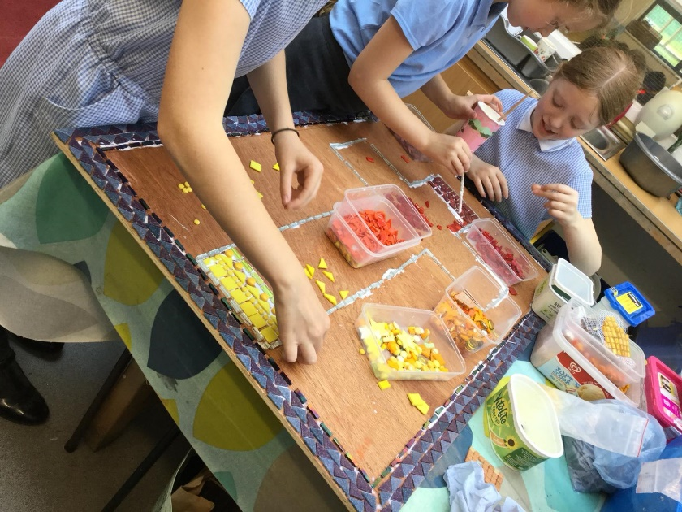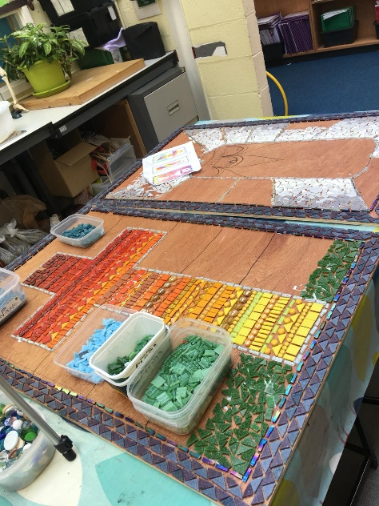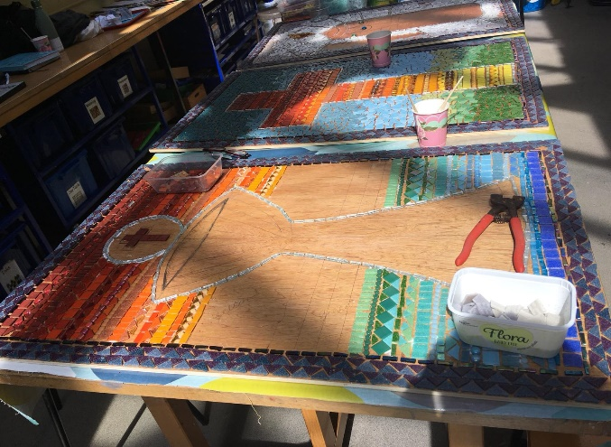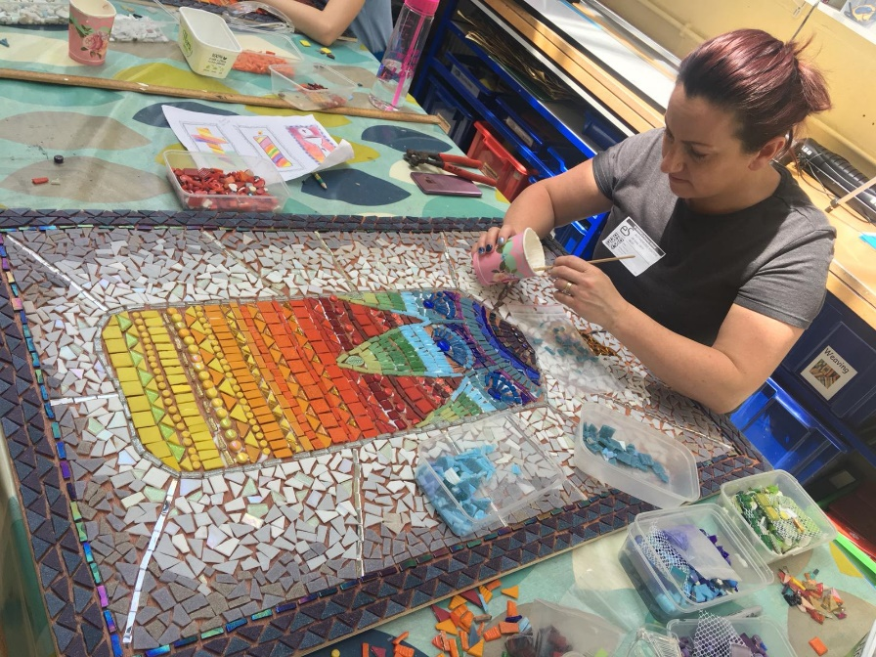

A Special Guest

'I went back to school today, 76 years after leaving in 1943, aged 14.
I was made welcome by the pupils I was going to be working with, all of them 11 years or so. I wondered how conversation was going to be, there was no problem. They were wonderful.
I was most impressed with their well-mannered confidence and enthusiasm with what they were doing. I really enjoyed my time with them. I hope I got a 9 out of 10!'
Thank you to everyone.
Albert Carney

Alberts Carney came to help the Mini Vinnies create the Mosaics in school. He came prepared, with his pockets full of school photographs and plenty of stories to tell. From tales about the war to anecdotes about his time at St Wilfrid’s and kept the children amused with his typical ‘(Grand)Dad Jokes’. He even found some mutual connections with the children’s family, which was no surprise as he seems to know half of Northwich! Not only did the children enjoy his stories, but he was equally interested in hearing about modern school life and was most amused by the fact he could hear children chatting away in the classroom, as 'you'd never get away with that in my day!'
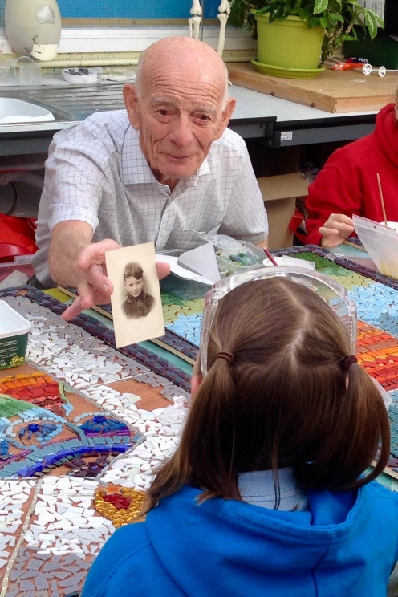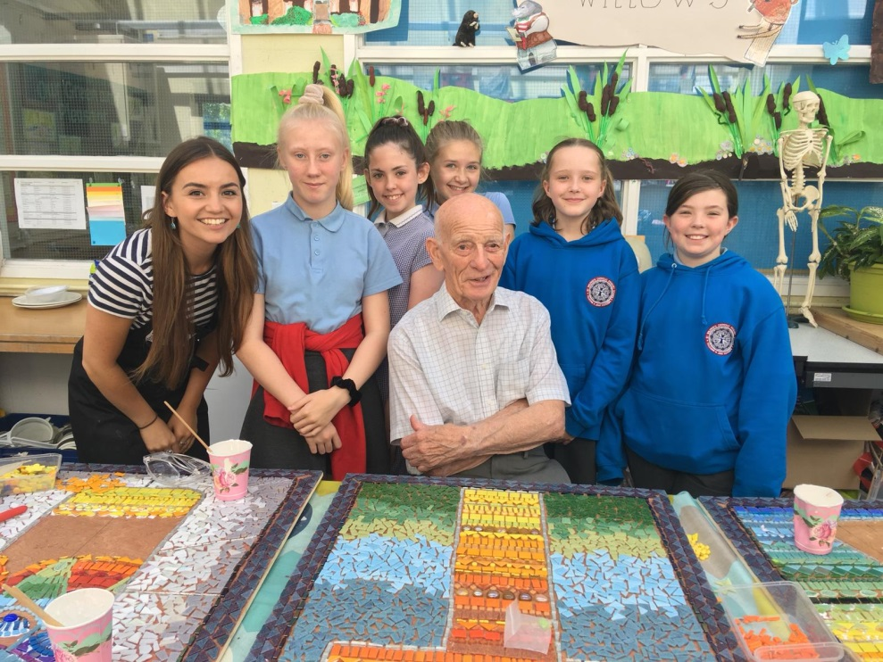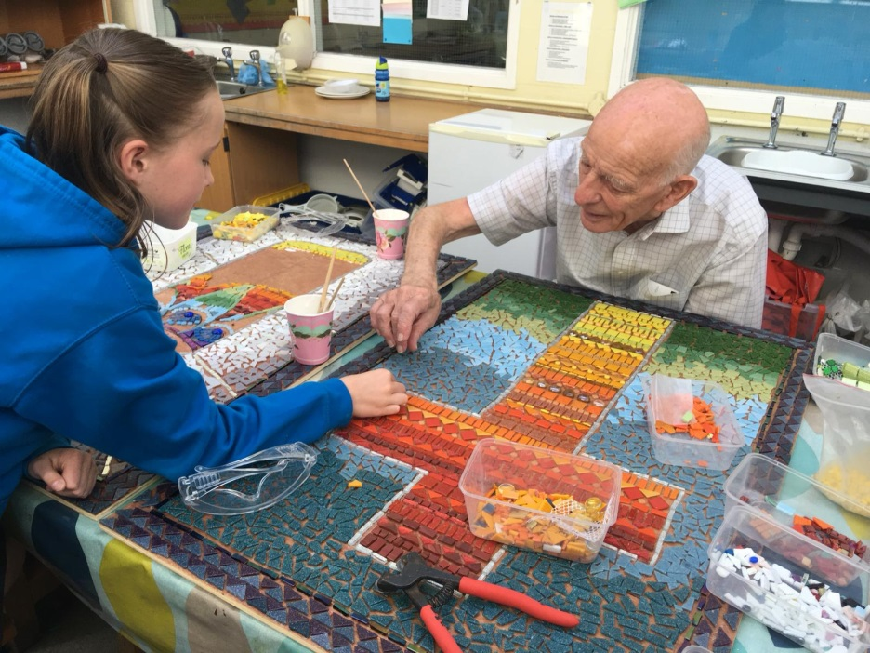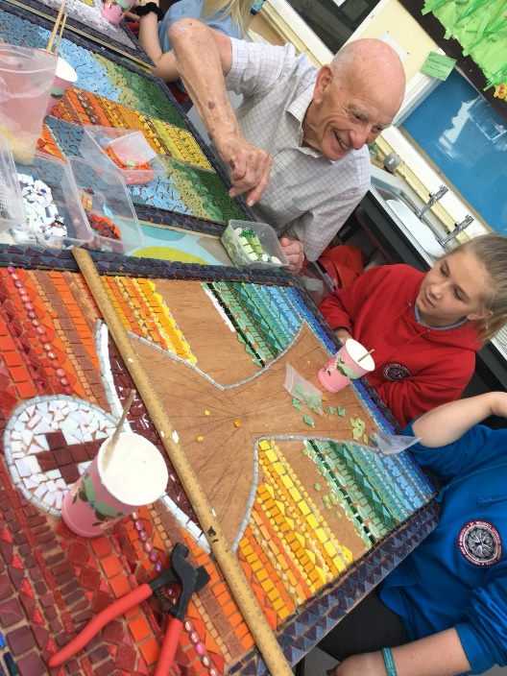

The designs, the finish product and our Mini Vinnies
