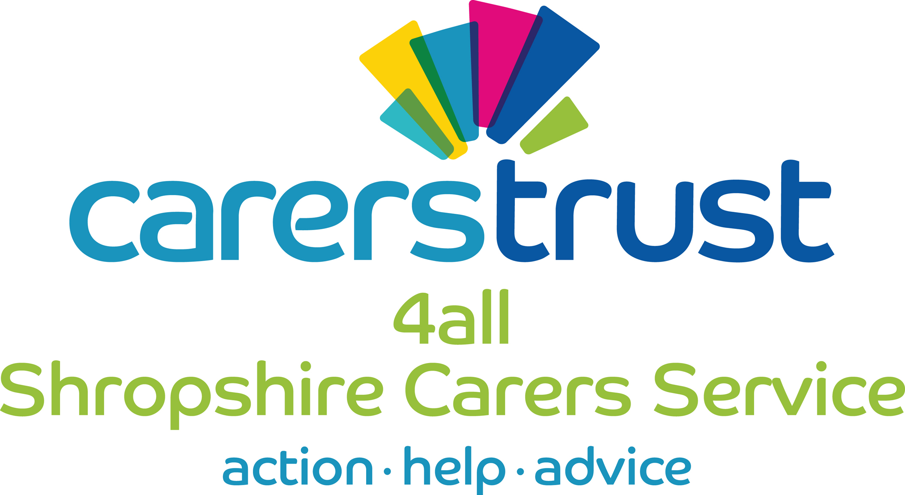
Cheshire West Young Carers
Young Carers Referral

Name of Young Person
Gender
Date of Birth

Address

Post code

Parent/Guardian names

Parent/Guardian contact numbers

Parent/Guardian email address

Preferred language
Ethnic Origin

Section A – Details of Person making the Referral
Charity Registration Number 1075268. Crossroads Care Cheshire, Manchester and Merseyside Limited (trading as Carers Trust 4all), is a company limited by guarantee registered in England number 3554493. Patrons: Rt Hon Lord Bradley, Fiona Bruce MP & Sir Nicholas Winterton. Registered office: Overton House, West Street, Congleton, Cheshire, CW12 1JY Tel: 01260 292850

Name

Job title (where applicable)

Organisation

Address

Telephone number

Email address

Where did you hear about our services

Section B – Details of the Young Person

School/college

School contact person (if known)

Average school attendance
Known to School as Young Carer?

Any special Educational Needs or EHCP?
GP Details

Known to GP as Young carers?

Do they attend any social groups outside of school? E.g. Scouts, Guides, Cadets etc.
Attending CAMHS?
On a waiting list for CAMHS

On a plan?

Open to TAF |  | Name of lead
Child in need |  | Contact details
Looked after Child
Child protection
Not on a plan
If not, have they in the past 12 months?

Additional information about the young person being referred. Tick where appropriate.
Refugee |  | Sensory : Hearing |  | Anger management
Excluded |  | Other health related issues |  | Physical / mobility
Homeless |  | Offending history |  | Learning disabilities
Current ASBO |  | Substance misuse |  | Sensory : Vision
Behaviour Issues |  | Sexualised behaviour |  | Diagnosed with Autism or Asperger Syndrome
 |  |  |  | Other DDA

Who do they share their home with?
Name | Relationship to young person | D.O.B
What is their carer’s status? Are they the main or secondary carer?

Primary Carer
Supported by parent
Supported by sibling/s

Section C – Details of the Cared For

The cared for (1)
Name:
Date of birth
Relationship to the young carer
Physical Disability |  | Terminal Illness
Learning Disability |  | Mental Illness
Alcohol Misuse |  | Physical Illness
Drug Misuse
What is their diagnosis?
How does it affect them? Paint a picture of how their condition effects them.

The cared for (2)
Name:
Date of birth
Relationship to the young carer
Physical Disability |  | Terminal Illness
Learning Disability |  | Mental Illness
Alcohol Misuse |  | Physical Illness
Drug Misuse
What is their diagnosis?
How does it affect them? Paint a picture of how their condition effects them.

The cared for (3)
Name:
Date of birth
Relationship to the young carer
Physical Disability |  | Terminal Illness
Learning Disability |  | Mental Illness
Alcohol Misuse |  | Physical Illness
Drug Misuse
What is their diagnosis?
How does it affect them? Paint a picture of how their condition effects them.

The cared for (4)
Name:
Date of birth
Relationship to the young carer
Physical Disability |  | Terminal Illness
Learning Disability |  | Mental Illness
Alcohol Misuse |  | Physical Illness
Drug Misuse
What is their diagnosis?
How does it affect them? Paint a picture of how their condition effects them.

Section D – Type of care being given and its potential impacts.

How do they provide care?
Describe their typical day or the nature of their caring role.
What is the impact of caring on the child/ young person?
Use the bullet points to help you explore possible impacts.
Emotional impact
- Do they have 1:1 support?
- How do they present?
- Any issues with self-injury?
Physical impact
- Any issues with sleep
- Are they eating well or have issues with food
- Any headaches, stomach complaints?
Social impact
- How well do they mix with other children?
- Do they isolate themselves?
- Are they able to bring friends home?
Educational impact
- Is their attendance effected?
- How do they mix with their peers in school?
- Are there any impacts on attainment?
Are there any identified risks of working with this young person? (behaviour, lone working)

Section D – Further information

Agencies that are supporting the young person or family:

Agency name | Worker name | Contact details | Service being provided

Are there any safeguarding or significant family circumstances that we need to be aware of?

Should we be aware of any personal safety issues when visiting the home?

Please tick to confirm

The young person is aware of the referral

The parent is aware of the referral

Young Person Signature |  | Date
Parent Signature |  | Date
Referrer Signature |  | Date

Please return the completed form to:
Cheshire West and Cheshire Young Carers Trust
Carers Trust 4 All
Unit 6
Rossmore Business Park
Ellesmere Port
CH65 3EY

Or by email to :
CWACYC@carerstrust4all.org.uk

If you would like to speak to someone regarding your referral
or have any queries please ring:
0333 323 1990

