

Festive tea lights, singing Santas and flashing Christmas wands are all powered by lithium button batteries, many of them easily accessible to curious little fingers.  
  
This Christmas we are asking families to keep potentially dangerous products out of reach of babies, toddlers and small children, and to be equally careful about where they store spare and used batteries. **Even an apparently ‘flat’ battery has enough power to cause serious harm if it gets stuck.**  
  
We’re concerned that small children put everything in their mouths, with potentially lethal consequences.

**[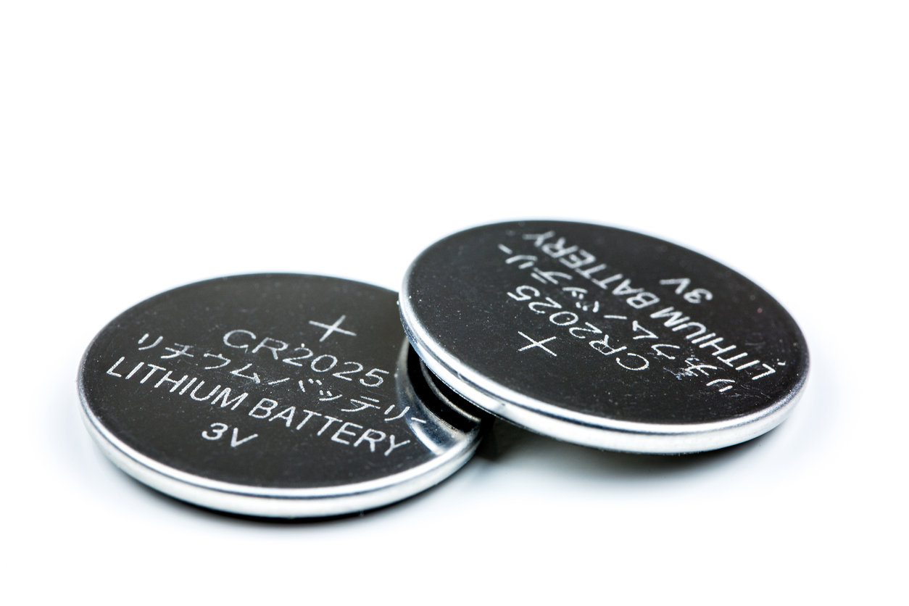](https://capt.us7.list-manage.com/track/click?u=f1346f3ff5a62d47baae512fa&id=ccf2f99c9f&e=71b7b3477a)**

**What’s the problem?**

Most button batteries pass through the body without a problem. But if a button battery - particularly a lithium coin battery gets stuck in the throat or gullet, energy from the battery reacts with saliva to make the body create caustic soda. This is the same chemical used to unblock drains!  
  
This can burn a hole through the throat and can lead to catastrophic internal bleeding and death. The reaction can happen in as little as two hours.  
All batteries pose a risk to children but the size and power of button batteries and the size of the child matter. With a large, powerful lithium coin cell battery and a small child, the risks are greatest.  
  
**It’s not just fully charged button batteries that pose a risk. Modern devices need a lot of power. When power levels drop, we think the battery is flat and discard it. But it can still have enough electrical charge left to badly injure a child.**  
  
Spare batteries are culprits too. Some lithium button batteries are individually sealed in the packet and can only be removed with scissors. But with other packets, especially cheaper ones, once you open them, all the batteries come out. So spares end up being stored in open containers or even loose in a drawer.  
  
Button batteries are also dangerous if they get stuck in a child’s nose or ear.

In this film, George Asan talks about his daughter Francesca, who died after swallowing a spare button battery.

[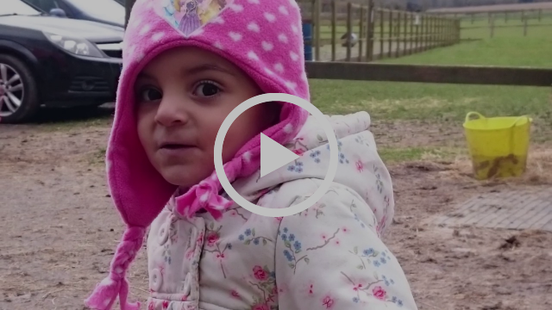](https://capt.us7.list-manage.com/track/click?u=f1346f3ff5a62d47baae512fa&id=35c4571216&e=71b7b3477a)

**Keep children safe this Christmas**

**from the risk of Button Batteries**



**How can you help keep children safe?**

* Keep all spare batteries in a sealed container out of children’s reach and sight, ideally in a high-up, lockable cupboard.
* Keep products with batteries well out of reach if the battery compartment isn’t secured.
* Put ‘flat’ or ‘dead’ batteries out of reach straight away and recycle them safely.
* Avoid toys from markets, discount stores or temporary shops as they may not conform to safety regulations, and take care when buying online or from overseas.
* Teach older children that button batteries are dangerous and not to play with them or give them to younger brothers and sisters.

**If you suspect a child has swallowed a button battery, act fast:**

* Take them straight to the A&E department at your local hospital or dial 999 for an ambulance.
* Tell the doctor that you think the child has swallowed a button battery.
* If you have the battery packaging or the product powered by the battery, take it with you. This will help the doctor identify the type of battery and make treatment easier.
* Do not let the child eat or drink.
* Do not make them sick.
* Trust your instincts and act fast – do not wait to see if any symptoms

develop.

**Help spread the word:**

* [**Click here to find out more about button batteries and the risks**](https://capt.us7.list-manage.com/track/click?u=f1346f3ff5a62d47baae512fa&id=deab259cdc&e=71b7b3477a) and share this information with your friends, family and colleagues.
* If you work with parents, a [**button battery safety pack**](https://capt.us7.list-manage.com/track/click?u=f1346f3ff5a62d47baae512fa&id=8aa8d0c67e&e=71b7b3477a), with a poster and 100 flyers, can help spread the word.

**More information**

The website of the British and Irish Portable Battery Association (BIPBA) has advice on the risks for parents and medical professionals -[**http://buttonbatterysafety.com**](https://capt.us7.list-manage.com/track/click?u=f1346f3ff5a62d47baae512fa&id=581e3a6221&e=71b7b3477a).

**Please help get the word out as widely as possible. With your support, children can be kept safe this Christmas from these devastating injuries.**

**Reference: Child Accident Prevention Trust** [**https://www.capt.org.uk**](https://www.capt.org.uk)



