St.Wilfrid’s Catholic Primary School PE & Sport funding 2017-18

The premium must be used to fund additional and sustainable improvements to the provision of PE and sport for the benefit of primary aged children and to encourage the development of healthy, active lifestyles.

It is expected that schools will see an improvement against the following 5 key indicators:
- The engagement of all pupils in regular physical activity, at least 1 hour of physical activity each day, 30 minutes should be in school
- The profile of PE and sport being raised across school as a tool for whole school improvement
- Increased confidence, knowledge and skills of all staff in teaching PE and sport
- A broader experience of a range of sports and activities offered to all children
- Increased participation in competitive sport

Sports Premium 2017-2018
Total number of children on role Y1-Y6 |  |  |  | 270
Lump sum |  |  |  | £15880
Amount per pupil |  |  |  | £2700
Total amount of Sports Premium funding |  |  |  | £18580
PE and Sport premium key indicator | Actions | Funding |  | Evidence | Impact | Evaluation
 |  | Planned | Actual
The engagement of all pupils in regular physical activity, | PE lead to attend VRSSP training  Increased numbers of children involved in L2 competitions/festivals  Intra sport activities (L1) to be organised and all KS2 children to be involved  Implement Maths of the Day  Implement 5 a Day Activities | £3698  £594 | £3698  £594 | Lesson Observations Maths of the Day  Lesson observations 5 a day  Registers for competitions/festivals | High levels of pupil involvement in physical activity  Children have access to a range of different physical activities  Staff have knowledge of ways to engage children in physical activity  Children have understanding of a healthy lifestyle | There is a high level of physical activity both in PE lessons and on the playground at lunch and break times  Children from KS2 attended Primary Skills and Performance Academies
The profile of PE, sport and healthy and active lifestyle being raised across school as a tool for whole school improvement | Y5 research group to determine if most children have a healthy lifestyle ( including levels of physical activity, healthy eating, good mental health) and to plan actions to make our school a healthy and happy place to learn  Cost towards providing Forest School  Pop Project – Healthy Lifestyles  Supply cover for promoting healthy lifestyles e.g Lets Walk/Bikeability | £1200  £1000  (supply cover)  £1000  £375  £750 | £1200  £1256  £1500  £375  £785 | Evidence gathered by Y5 research group and presentation at conference | Children, staff, governors have clear view of what a healthy lifestyle means in our school  Maintain high levels of physical in lessons and during break and lunchtimes  Healthy snacks available at playtime  School dinners meet healthy eating requirements  Growth mindset and yoga support healthy minds | Children have an awareness of the importance of healthy eating and the importance of sleep and friendships as part of their well being  Governors and staff have an understanding of how to make our school a happy and healthy place to learn and how they can support this
Increased confidence, knowledge and skills of all staff in teaching PE and sport | Staff including PE lead to attend a variety of training courses provided by VRSSP and feedback at staff meetings  Co- teaching with Carolyn Reid (PE teacher St. Nicholas High School)  In house expertise to be used to support less confident teachers: joint planning, team teaching, sharing resources  Teaching resources to be kept up to date | £500 | £628 | Lesson observations  Pupil voice  Feedback from staff | Teachers planning and delivering challenging a lessons with good levels of pupil involvement  Good levels of engagement and enjoyment in lessons  Some differentiation of skills in lessons  Teachers confident in using appropriate language when giving feedback | Improved quality of teaching and learning in lessons  Children show positive attitudes to PE and sport  Specialist coach worked to support in Y5/6  Staff with expertise worked to support less confident staff
A broader experience of a range of sports and activities offered to all children | Provide a wider range of extra curricular activities ( subsidised or free) with specialist coaches: judo, cricket, athletics, archery, gymnastics  Target least active children and PP children by offering free places  Train all teachers and teaching assistants to deliver mini-me yoga ( not from sports premium) and purchase resources to support delivery  Attendance at G & T academies | £1695  £400 | £1695  £205 | Extra curricular registers  Pupil voice/research group | Increase in range of clubs/activities available  Feedback from pupil research group evidenced most children are involved in physical activity  Activities available at lunchtime for all children: skipping, dancing, fitness/activity | The participation at some extra curricular activities has been less than expected. Distance children have to travel has an impact and parents are not always able to pick up after school.  The child initiated activities have been well supported and children often those less active have participated.  Mini –me yoga offered as an afterschool club was over subscribed  Yoga activities used by staff in both Key Stages as a PE activity or part of a lesson
Increased participation in competitive sport | Engage with VRSSP  Employ specialist coaches to co deliver lessons with class teachers/HLTA  Establish and maintain partnerships with local schools and community sports clubs  Plan a range of intra competitions (L1) which can be accessed by KS2 children  Enter L2 competitions, select increased number of children and teams to participate in local competitions  Annual audit to support plans for provision in line with best practices  Apply for Silver Mark | £5000  £1000  £1000 | £4442  Cover  £628  Transport  £500  £1099 | School data  Sports display board  List of events/fixtures  School newsletter  Twitter  Account VRSSP | Majority of children entered intra school competition  School entered 10+ interschool competitions  B teams participated in 5 events  School provides opportunities for intra school events: 3+  Broaden the range of children participating in inter school events | School achieved bronze award  Wider range of children participated in inter school competitions  Inspirational visit from Jenna Downing increased confidence and aspirations particularly of girls  Y6 leaders provided activities at lunchtimes for KS1 and KS2 children with increased numbers having a go  A team was entered in almost all events in school sports week

What percentage of your current Y6 cohort perform safe self -rescue in different water –based situations? | _______
Percentage of Y6 children who can swim for 25m | 90%
Percentage of children who can swim using a range of strokes ( front crawl, back crawl, breast stroke) | 90%

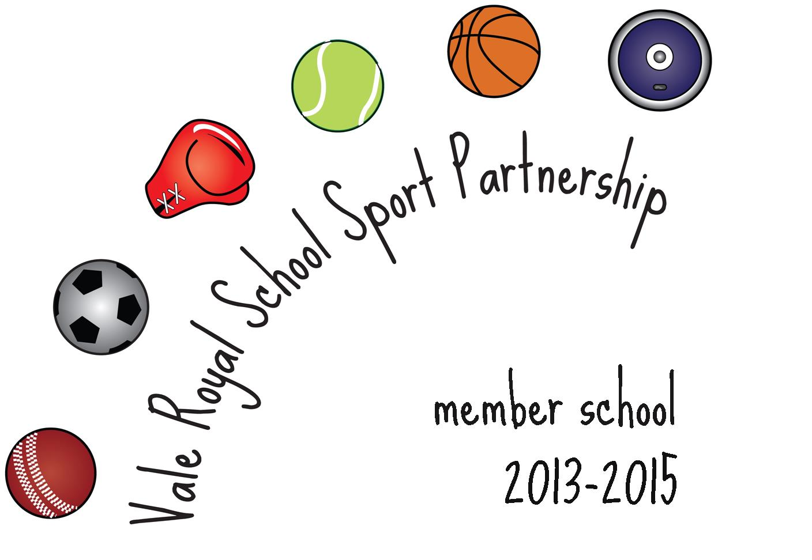

PE and Sport School Grant

