Primary PE & Sport funding 2016-17

This year at St Wilfrid’s Primary School we aim to utilise the Primary PE & Sport funding to improve the quality and breadth of our PE & Sport provision through continually developing teaching and learning in PE, encouraging our pupils to adopt healthy active lifestyles and to take part in a wide range of sports and physical activities including more competitive school sport.

Specifically we will:

Aim | How we will meet this aim | Outcome
Provide opportunities for children across KS1 and 2 to participate in competitive sports. | Continue with membership of the Vale Royal School Sports Partnership enabling us to take part in cluster tournaments and festivals.  Competitions entered:  Sports hall athletics (2nd place), cross country(individual winners only), dodgeball, football, hockey, netball, quad kids (6th place), boccia (winners of cluster competition) | As school we have participated in a variety of events including: football, Boccia, hockey, netball, tag rugby and football.  Being part of the partnership has also allowed us to benefit from co-delivery sessions with a PE specialist from St Nicholas. The children in year 5/6 had gymnastics sessions whilst year 3/4 and 1 / 2 participated in athletics and basic skills sessions.
Provide different ways for all children to be active in PE but also through physical activities outside of the curriculum | use 5-a-day fitness in school to provide children with a fun way to be active  We ensure every child has the opportunity to get involved in extra-curricular activity whether at breakfast clubs, lunchtimes, playtimes or in after-school clubs. We will provide a variety of clubs each term that children may or may not have to pay for.  Bikeability offered to y5  Over 30 pupils took part in this training 29 achieving level 2 | 5-a-day fitness has continued to be used across the school – sometimes during wet play or as brain break activities.  Children in y5 took part in a bikeability course to ensure they know how to travel safely.
Develop active playtimes | To train Year 5 children in Playground Leaders.  For the Playground Leaders to become independent when leading games for younger children.  For the playground to be zoned – allowing other sporting skills to be practiced.  To make improvements to the school playground that will benefit pupils in future years. | A group of y5 pupils visited a local primary school to compare provision. They created and sent out a pupil voice questionnaire and are now in the process of collating results and acting upon them.  Mid-day assistants continue to deliver daily play sessions to pupils at lunchtime. All pupils have the option to take part. The midday assistants have encouraged active, safe games at lunchtime which has increased fitness levels and impacted positively on lunchtime behaviour.
Only work with coaches who are appropriately qualified and checked | To source coaches with our School Partnership with the correct level of training in the sport offered, as well as further training on safeguarding and protecting children, Emergency 1st Aid and who are fully insured to work with our children. We will select coaches who provide support both in lessons and after school clubs. | Coaches have come in to school to deliver specialist cricket sessions for the children. All coaches were sourced in accordance with our school partnership.  This has led to an increased staff confidence in teaching dance, hockey and cricket.
Make sure our PE Subject Leader has appropriate assistance to develop our PE & School Sport offer and support our teachers effectively | The PE & School Sport Subject Leader will attend regular leadership training and receive focused support from Vale Royal School Sport Partnership & Youth Sport Trust trainers. | PE subject leader has attended all leadership training and meetings.
Review our provision to make sure the funding is spent to bring about maximise the development of PE & Sport | Undergo an annual audit and plan our provision in line with the accepted best practices, which will include applying for a Youth Sport Trust Quality Mark for Physical Education and the Sainsbury’s School Games Kite Mark for participation in competitive school sport | An audit was carried out by from this audit resources were then either purchased from sports premium or sourced and “purchased” through the Sainsbury’s active kids scheme.
To encourage and promote gifted and talented pupils. | To enrol nominated children on the primary performance academy.  4 year 4 pupils attended PSA  3 year 6 pupils attended PPA | Children from y6 and y4were nominated to attend the primary performance academy and the primary skills academy. Sports premium funded the pupils for this.
Cricket  (Chance 2 Shine)  CPD/Coaching | To enable children to develop skills in Cricket. For children to use Cricket style games at playtime rather than football.  For staff to be confident in teaching Cricket.  To develop links with Weaverham Cricket Club | Children in year 3 and 4 and 5 and 6 have had the opportunity for coaching.  Children in KS1 have had a taster session – encouraging them to attend their local cricket club where they can access coaching at a reduced rate.
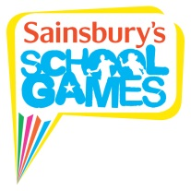
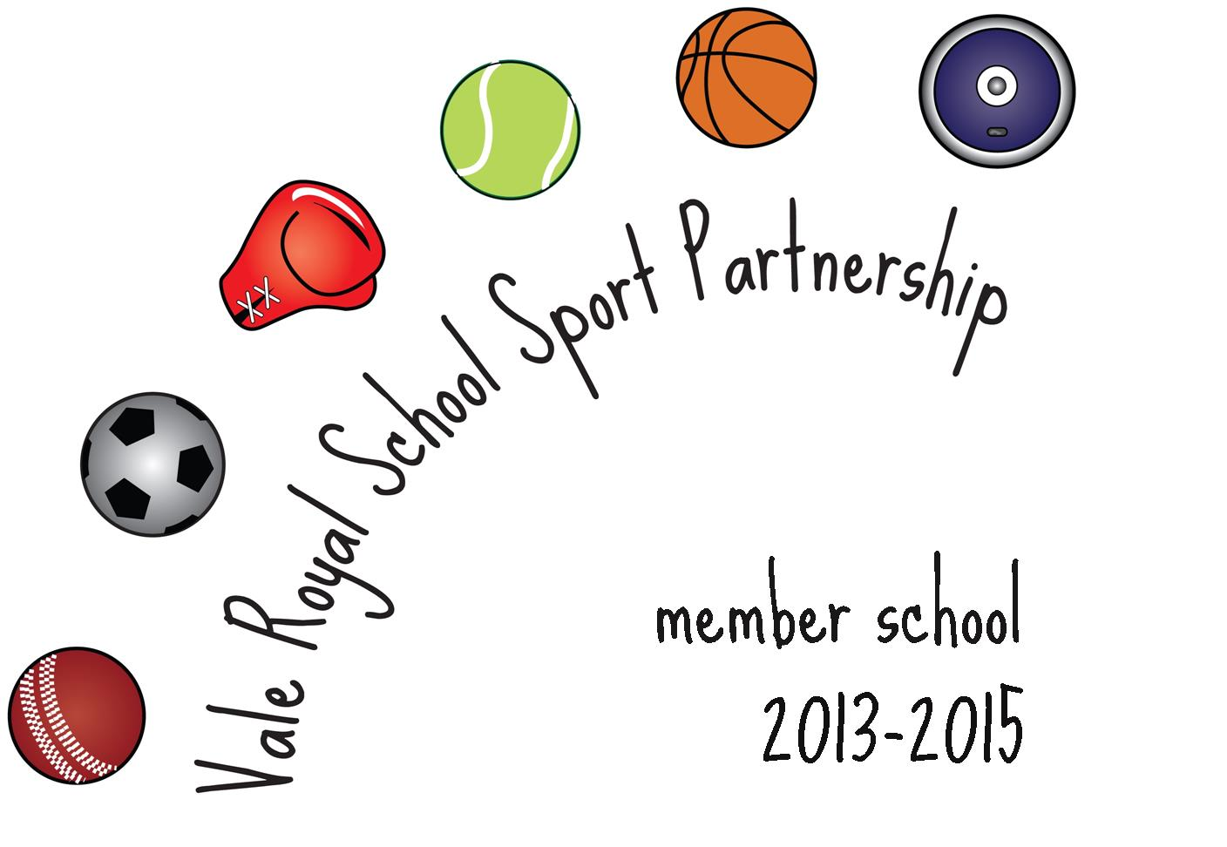

PE and Sport School Grant
Autumn 2016- July 2017  Our allocation of £9300 has been used as follows | Expenditure
Membership of Vale Royal School Sports Partnership | £3423
Playground resurfacing to ensure safety at playtime and PE and to enable PE lessons to continue even after bad weather | £6000
Yoga training for staff | £1000
Attendance for y4 (4 pupils) and Y6 (3 pupils) to academies (G&T) | £360
Supply cover for subject leader and staff training | £150
TOTAL | £10,933

The additional £1633 has been allocated from the school budget.

