Mini Vinnies
Silly Sock Day
Friday 12th May 2017

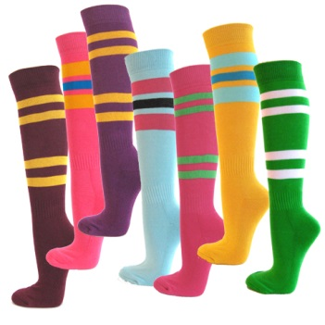

Wear Silly socks and donate 20p to Mini Vinnies
or bring a packet or tin for the FoodBank

